**IFT-511- Analyzing Big Data  
Project Step-4: Model Building and Evaluation  
Asmaa Elbadrawy  
Date- 04/30/2024**

**Team – Gamma**

**Kishore Prashanth – 1230355479  
Shri Harri Priya Ramesh – 1229611021  
Ashwani Kumar Guntupalli – 1230762236  
Hemanth Kumar Guntupalli – 1230142149**

Table of Contents

Task Description 3

Model Building and Evaluation 3

Label Encoding of Categorical Cities for Machine Learning Preprocessing 6

Label Encoding of Categorical Zipcodes for Machine Learning Preprocessing 7

Identifying Expense Columns to Drop from the School Raw Data 8

Dropping Expense Columns from the School Data 9

Range Exporter Function for Quantile Calculation 10

Simplified School Selection Criteria Input and Filtering 13

Simplified School Selection Criteria with Race Constraints 14

School Selection Criteria Input 15

School Selection Criteria Input DataFrame Shape 19

Finding Nearest Schools using K-Nearest Neighbors 20

Random Forest Classifier Predictions and School Data Retrieval 22

Support Vector Classifier (SVC) 23

Obtained Results 25

Extra Credit - Plan 27

Extra Credit - Data Recollection 27

Collecting Additional Data from School Websites 27

Extra Credit - Model Re-Building 57

Loading and Preparing Additional School Data 57

Conversion and One-Hot Encoding of Categorical Columns 59

Preparing Additional School Test Set 61

Finding the 5 Nearest Schools using K-Nearest Neighbors (KNN) Algorithm 64

Predicting Schools with Random Forest Classifier 65

Selecting Top 5 Predicted Schools with SVC Classifier 67

New Results 69

Full Code 71

Task Description

The goal of this project is to develop a data-driven school recommendation system that can assist families in the Phoenix metropolitan area who are relocating and seeking suitable K-12 schools for their children. Due to time and resource constraints, these families are unable to thoroughly research all available options, so the "recommendation" engine will utilize data mining techniques to identify the top 5 schools that are most similar to a given school. The project will involve evaluating various machine learning models, such as KNN (K-Nearest Neighbors) and RNN (Recurrent Neural Networks), to identify the most suitable approach for the recommendation task.

The key attributes that will be collected and utilized for the school recommendation system include:

1. City or Zipcode: The system will allow users to specify either the city or zipcode where they want to find schools.
2. School Levels: Users can indicate if they require the school to have elementary, intermediate, middle, or high school level classes.
3. School Grade Constraints: Users can specify a range of grades (1-5) that they prefer for the school, with 1 being the least preferred and 5 being the highest.
4. Title I Status: Users can specify if they want the recommended schools to have Title I status or not.
5. Total Students: Users can provide a minimum number of students they want in the recommended schools, either less than or greater than 1000 students.

Model Building and Evaluation

Our code will collect the user inputs for these attributes. It basically uses a city_number_converter or zipcode_number_converter to convert the entered city or zipcode into a numerical value. Additionally, it prompts users to input their preferences for school levels, grade constraints, Title I status, and the minimum number of students.

The collected user inputs will be used to filter and rank the available school options based on their similarity to the specified preferences. The project will involve evaluating different machine learning models, such as KNN (K-Nearest Neighbors) and RNN (Recurrent Neural Networks), to determine the most effective approach for generating personalized school recommendations based on the given criteria.

Code

import pandas as pd

from sklearn.preprocessing import LabelEncoder

from sklearn.neighbors import KNeighborsClassifier

from sklearn.ensemble import RandomForestClassifier

from sklearn.svm import SVC

import ast

from sklearn.preprocessing import MultiLabelBinarizer

import re

Checking if the dataset is loaded

school_raw_data = pd.read_csv("../511_project_Step_3.csv")

school_raw_data.head(5)

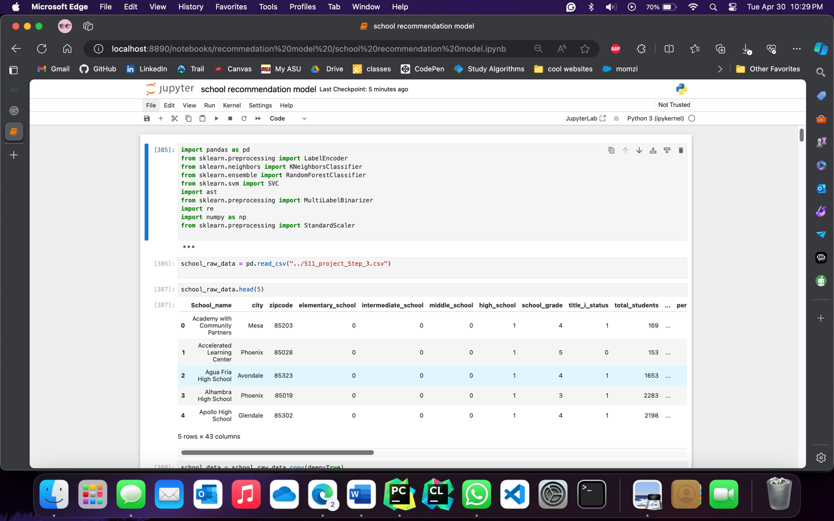

**Creating a Deep Copy of the School Raw Data**

We created a deep copy of the school_raw_data DataFrame and assigned it to the school_data DataFrame. By using the copy() method with the parameter deep=True, a separate copy of the data is created, ensuring that any changes made to the school_data DataFrame do not affect the original school_raw_data DataFrame. This deep copy allows for independent data manipulation and preprocessing steps to be performed on the school_data DataFrame without altering the original dataset.

Code

school_data = school_raw_data.copy(deep=True)

school_data

Image

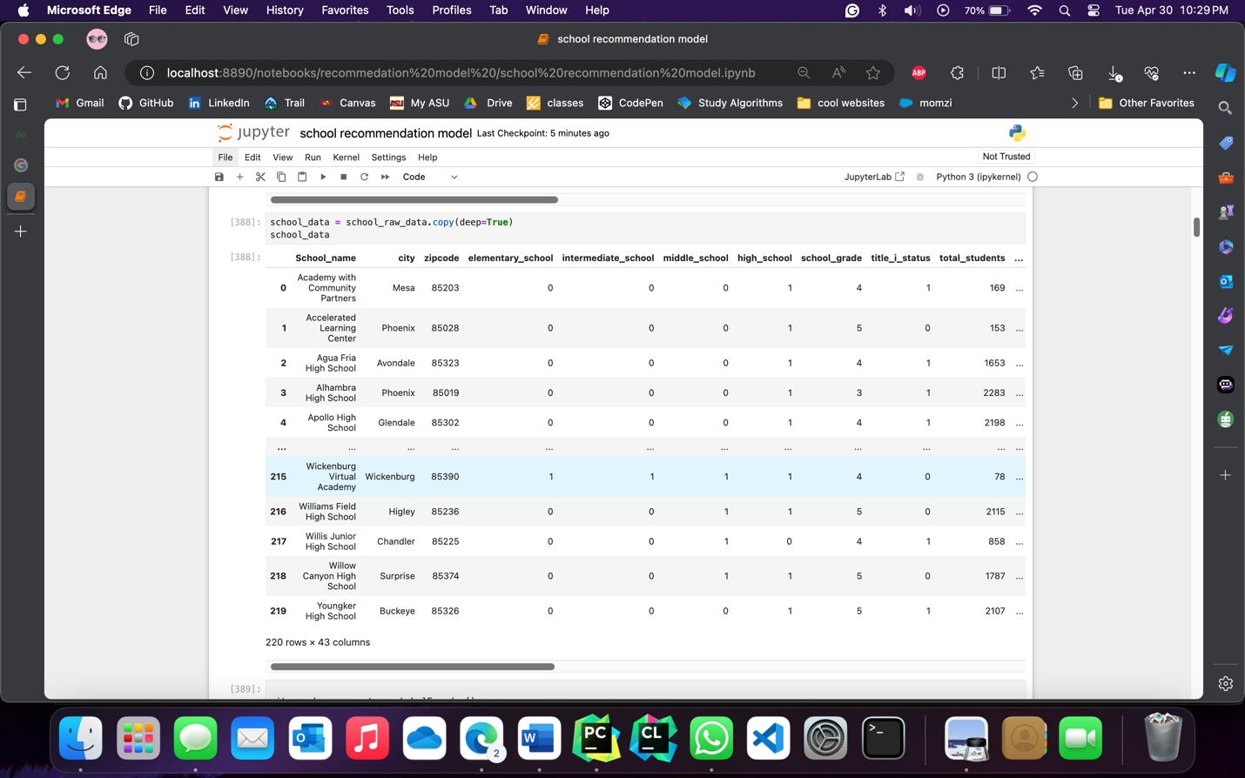

Label Encoding of Categorical Cities for Machine Learning Preprocessing

We now perform a label encoding on the 'city' column of the school_data DataFrame. Using the LabelEncoder class, the categorical city names are transformed into numerical values. The resulting DataFrame, school_data, displays the first 5 rows with the updated 'city' column containing the encoded numerical values. This preprocessing step is commonly employed in machine learning projects to convert categorical data into a numerical format suitable for analysis and modeling.

Code

city_number_converter = LabelEncoder()

school_data['city']= city_number_converter.fit_transform(school_raw_data['city'])

school_data.head(5)

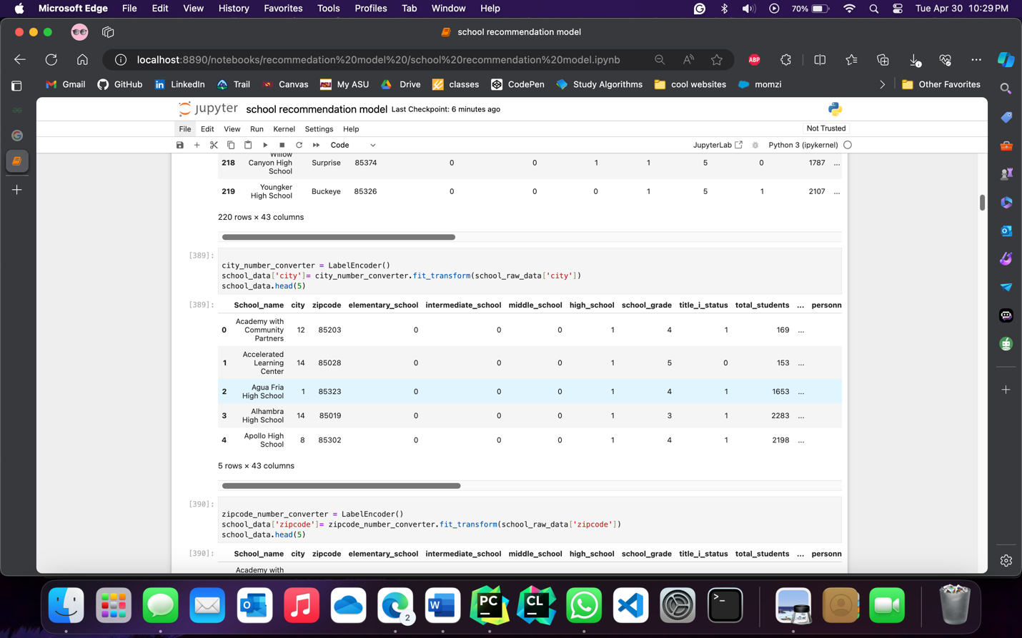

Label Encoding of Categorical Zipcodes for Machine Learning Preprocessing

Here we performed label encoding on the 'zipcode' column of the school_data DataFrame. It converts categorical zipcodes into numerical values using the LabelEncoder class and updates the 'zipcode' column accordingly. The resulting DataFrame, school_data, shows the first 5 rows with the transformed 'zipcode' column. This preprocessing step is commonly used in machine learning projects to convert categorical data into a numerical format suitable for analysis and modeling.

Code

zipcode_number_converter = LabelEncoder()

school_data['zipcode']= zipcode_number_converter.fit_transform(school_raw_data['zipcode'])

school_data.head(5)

Image

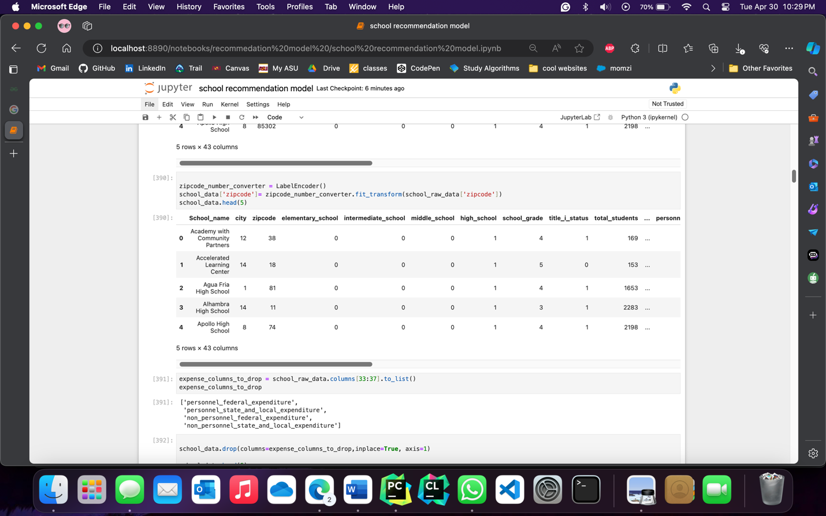

Identifying Expense Columns to Drop from the School Raw Data

Here a range of columns in the school_raw_data DataFrame represent expenses. Columns 33 to 36 are selected using Python indexing and stored as a list in expense_columns_to_drop. These columns can be dropped from further analysis or preprocessing to streamline the data and reduce dimensionality.

Code

expense_columns_to_drop = school_raw_data.columns[33:37].to_list()

expense_columns_to_drop

Image

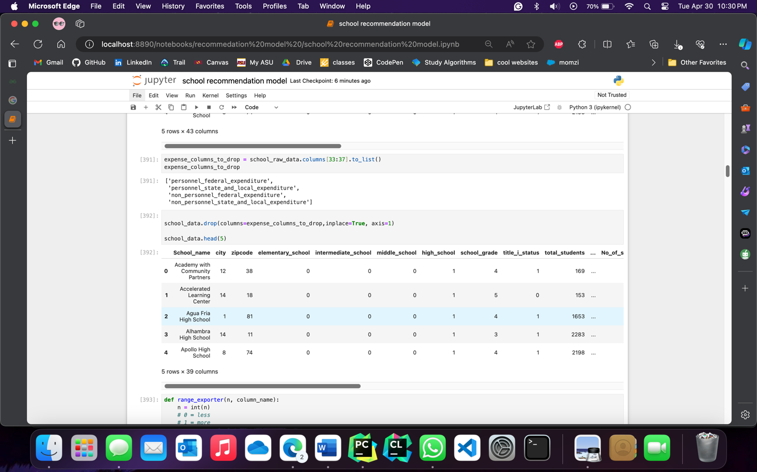

Dropping Expense Columns from the School Data

We now drop the expense columns from the school_data DataFrame. The drop() method is used with the columns parameter set to expense_columns_to_drop, which contains the list of expense columns identified earlier. The inplace=True parameter ensures that the changes are made directly to the school_data DataFrame. The resulting DataFrame is displayed, showing the first 5 rows after removing the expense columns. This step is crucial for streamlining the data and focusing on the relevant features for further analysis and modeling.

Code

school_data.drop(columns=expense_columns_to_drop,inplace=True, axis=1)

school_data.head(5)

Image

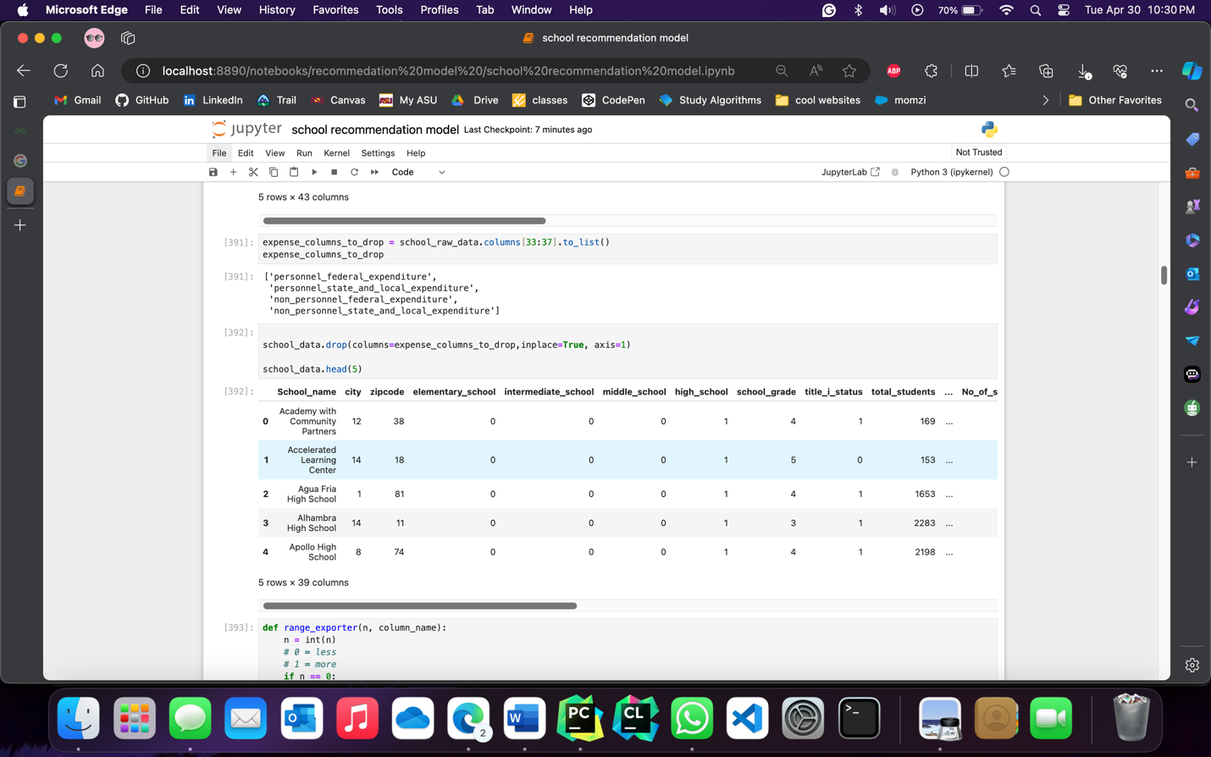

Range Exporter Function for Quantile Calculation

The below code defines a function called range_exporter that calculates quantiles for a given column_name in the school_data DataFrame. The function takes an additional parameter n, which represents the desired quantile range:

* When n is 0, the function returns the 40th percentile of the column_name.
* When n is 1, the function returns the 60th percentile of the column_name.
* When n is 2, the function returns the 80th percentile of the column_name.

The column_name is assumed to be a valid column in the school_data DataFrame. The function converts n to an integer to ensure proper comparison. The quantile values are obtained using the quantile() method on the column_name of school_data. This function is useful for extracting specific quantile ranges for further analysis or data preprocessing.

Code

def range_exporter(n, column_name):

n = int(n)

# 0 = less

# 1 = more

if n == 0:

return school_data[column_name].quantile([0.40])[0.40]

elif n == 1:

return school_data[column_name].quantile([0.60])[0.60]

elif n == 2:

return school_data[column_name].quantile([0.80])[0.80]

Image

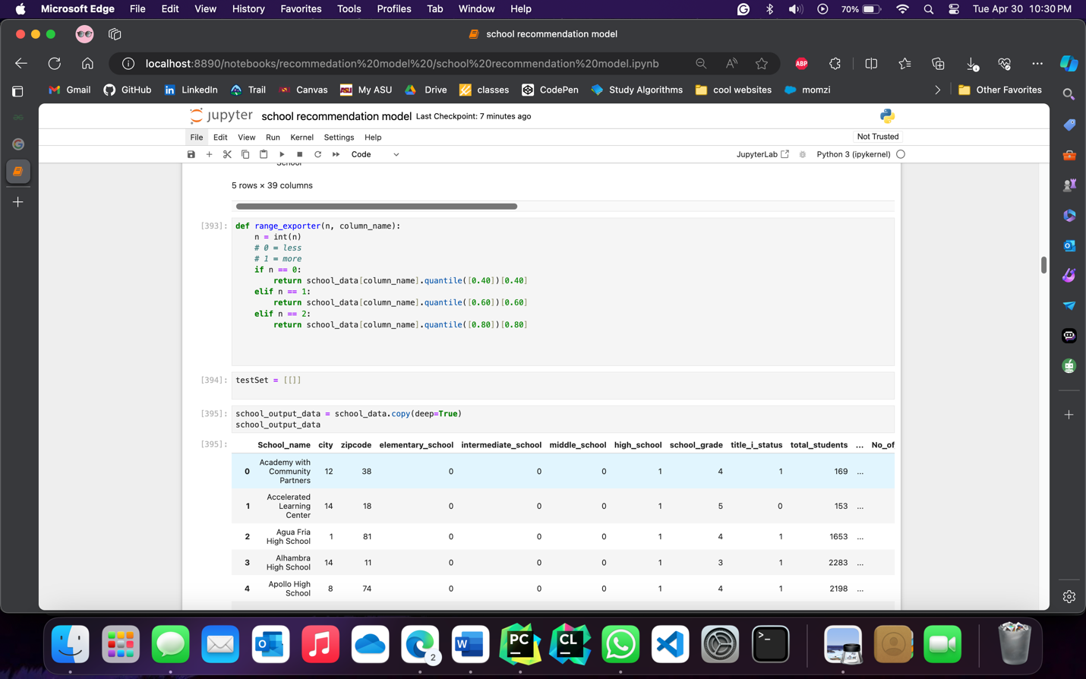

**Creating a Deep Copy of the School Data**

We created a deep copy of the school_data DataFrame and assigned it to the school_output_data DataFrame. By using the copy() method with the parameter deep=True, a separate copy of the data is created, ensuring that any changes made to the school_output_data DataFrame do not affect the original school_data DataFrame. Then the school data is scaled

Code

school_output_data = school_data.copy(deep=True)

school_output_data

scaler = StandardScaler()

school_data = pd.DataFrame(scaler.fit_transform(school_data.iloc[:,1:]))

Image

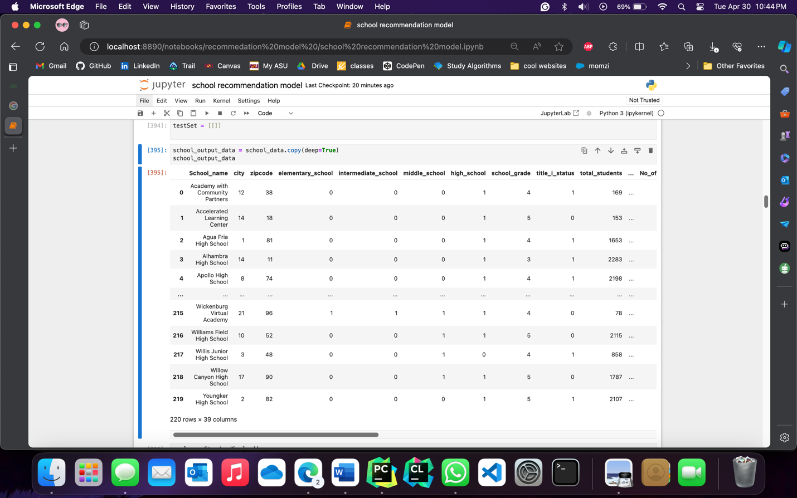

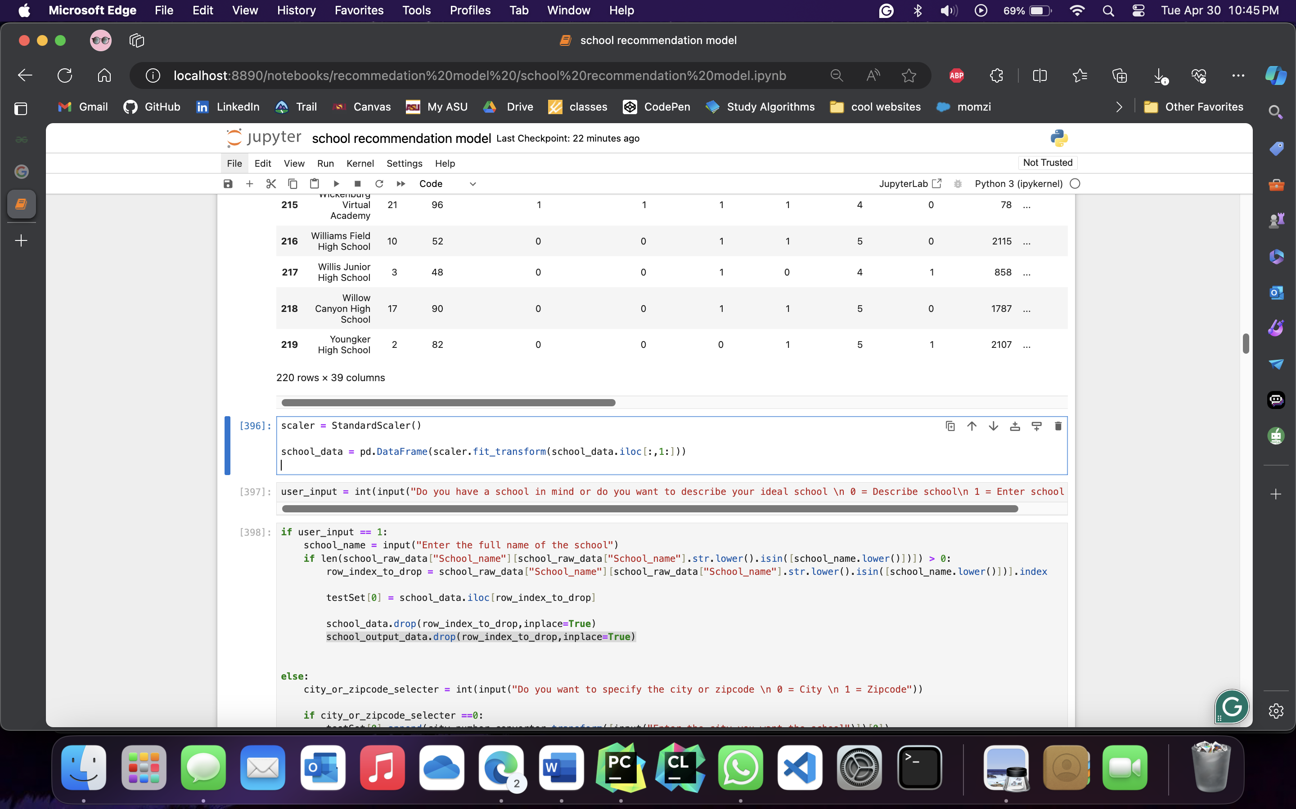

Simplified School Selection Criteria Input and Filtering

First, the user is prompted to specify whether they want to input the city or zipcode preference. They can enter either 0 for the city or 1 for the zipcode.

If the user selects 0 for the city, the code prompts them to enter the desired city name. The city_number_converter transformer is then used to convert the city input into a numerical value, which is appended to the testSet list. Additionally, the 'zipcode' column is dropped from the school_data DataFrame to filter the data based on the user's city preference.

If the user selects 1 for the zipcode, the code prompts them to enter the desired zipcode. The zipcode_number_converter transformer is used to convert the zipcode input into a numerical value, which is then appended to the testSet list. Similarly, the 'city' column is dropped from the school_data DataFrame to filter the data based on the user's zipcode preference.

Next, the code prompts the user to input their preferences for elementary, intermediate, middle, and high level classes in the school. The user can enter either 0 for "No" or 1 for "Yes" for each grade level, and these values are appended to the testSet list.

The user is then asked to input the grade constraints for the school, ranging from 1 to 5. The input value is appended to the testSet list.

The user is further prompted to specify whether they want schools with Title I status. Similar to previous inputs, the user can enter 0 for "No" or 1 for "Yes", and the value is appended to the testSet list.

Finally, the user is asked to enter the minimum number of students they want in the school. The range_exporter function is used to calculate the appropriate quantile range for the 'total_students' column based on the user's input. The function takes in the user's choice of 0 for "Less than 1000" or 1 for "Greater than 1000", and the result is appended to the testSet list.

Simplified School Selection Criteria with Race Constraints

we have added an option for the user to specify race constraints for school selection. The options are as follows:

* 0: African American
* 1: Hispanic
* 2: Native American
* 3: White
* 4: Multiple Race
* 5: Asian
* 6: Pacific Islander

Based on the user's race selection, the corresponding columns related to race in the school_raw_data DataFrame are identified and stored in the race_columns_to_drop list. If the selected race column is already present in the list, it is removed to ensure it is not dropped from the DataFrame.

Next, the identified race columns are dropped from the school_data DataFrame using the drop function, simplifying the data based on the user's race constraint.

Finally, the user is asked to enter the percentage range for the selected race. They can choose from the following options:

* 0: Low
* 1: Medium
* 2: High

The range_exporter function is used to calculate the appropriate quantile range for the selected race column in school_raw_data based on the user's percentage input. The range is then appended to the testSet list.

School Selection Criteria Input

This allows users to input various constraints and preferences for selecting schools based on specific criteria. The user is prompted to provide inputs for different factors such as proficiency points, graduation rate, minimum dropout rate, CCRI points, promotion rate, advanced placement courses support, chronic absenteeism level, crime rate level, bullying level, total per pupil expenditure level, and various school/district policies. The user can select the desired level for each criterion, such as low, medium, or high, or provide a specific value within a range. These inputs are stored in the testSet list for further analysis and processing. With this code, users can customize their school selection process based on their specific preferences and constraints.

Code

testSet = [[]]

user_input = int(input("Do you have a school in mind or do you want to describe your ideal school \n 0 = Describe school\n 1 = Enter school name "))

if user_input == 1:

school_name = input("Enter the full name of the school")

if len(school_raw_data["School_name"][school_raw_data["School_name"].str.lower().isin([school_name.lower()])]) > 0:

row_index_to_drop = school_raw_data["School_name"][school_raw_data["School_name"].str.lower().isin([school_name.lower()])].index

testSet[0] = school_data.iloc[row_index_to_drop,1:]

school_data.drop(row_index_to_drop,inplace=True)

school_output_data.drop(row_index_to_drop,inplace=True)

else:

city_or_zipcode_selecter = int(input("Do you want to specify the city or zipcode \n 0 = City \n 1 = Zipcode"))

if city_or_zipcode_selecter ==0:

testSet[0].append(city_number_converter.transform([input("Enter the city you want the school")])[0])

school_data.drop(columns=['zipcode'],inplace=True, axis=1)

else:

testSet[0].append(zipcode_number_converter.transform([input("Enter the zipcode you want the school")])[0])

school_data.drop(columns=['city'],inplace=True, axis=1)

testSet[0].append(input("Should the school have elementary level classes: \n 0 = No \n 1 = Yes"))

testSet[0].append(input("Should the school have intermediate level classes: \n 0 = No \n 1 = Yes"))

testSet[0].append(input("Should the school have middle level classes: \n 0 = No \n 1 = Yes"))

testSet[0].append(input("Should the school have high level classes: \n 0 = No \n 1 = Yes"))

testSet[0].append(input("Enter school grade constraints: [1-5]\n 1 being least and 5 being highest"))

testSet[0].append(input("Should the school have Title I: \n 0 = No \n 1 = Yes"))

testSet[0].append( range_exporter(input("Enter the minimum number of students you want in the school: \n 0 = Less than 1000 \n 1 = Greater than 1000"),'total_students'))

# if int(input("Do you want to specify any race contraints? \n 0 = No \n 1 = Yes")) ==1:

race = int(input("Enter your race constraint \n 0 = African American \n 1 = Hispanic \n 2 = Native American\n 3 = White\n 4 = Multiple Race \n 5 = Asian\n 6 = Pacific Islander "))

race_columns_to_drop = school_raw_data.columns[10:24].to_list()

if school_raw_data.columns[(race*2) +11 -1] in race_columns_to_drop:

race_columns_to_drop.remove(school_raw_data.columns[(race*2) +11 -1])

school_data.drop(columns=race_columns_to_drop,inplace=True, axis=1)

testSet[0].append(range_exporter(input("Enter the percentage of the race: \n0 = Low \n 1 = Medium \n 2 = High"),school_raw_data.columns[(race*2) +11 -1]))

testSet[0].append(range_exporter(input("Enter the proficiency points constraints: \n0 = Low \n 1 = Medium \n 2 = High"),'proficiency_pts'))

testSet[0].append(input("Enter the graduation rate constraints: [0-10]\n 0 being least and 10 being highest"))

testSet[0].append(range_exporter(input("Enter the minimum dropout rate level: \n0 = Low \n 1 = Medium \n 2 = High"),'Dropout_rate'))

testSet[0].append(range_exporter(input("Enter the CCRI points level: \n0 = Low \n 1 = Medium \n 2 = High"),'CCRI_points'))

testSet[0].append(range_exporter(input("Enter the promotion rate level: \n0 = Low \n 1 = Medium \n 2 = High"),'promotion_rate'))

testSet[0].append(range_exporter(input("Advanced placement courses support level:\n0 = Low \n 1 = Medium \n 2 = High"),'No_of_students_adv_placement_course'))

testSet[0].append(range_exporter(input("Chronic absenteeism level:\n0 = Low \n 1 = Medium \n 2 = High"),'Students_with_Chronic_Absenteeism'))

testSet[0].append(range_exporter(input("Crime rate level:\n0 = Low \n 1 = Medium \n 2 = High"),'crime_rate'))

testSet[0].append(range_exporter(input("Bullying level:\n0 = Low \n 1 = Medium \n 2 = High"),'total_students_bullied'))

testSet[0].append(range_exporter(input("Total per pupil expenditure level:\n0 = Low \n 1 = Medium \n 2 = High"),'total_per_pupil_expenditure'))

testSet[0].append(input("Should the school protect excessive distractions labeled as Social Emotional Learning: \n 0 = No \n 1 = Yes"))

testSet[0].append(input("Should the school/district appropriately respect all students as individuals: \n 0 = No \n 1 = Yes"))

testSet[0].append(input("Should the school/district fully support teacher discipline recommendations: \n 0 = No \n 1 = Yes"))

testSet[0].append(input("Should the school teach sexual content that is developmentally appropriate: \n 0 = No \n 1 = Yes"))

testSet[0].append(input("Should the curriculum at school not expose students to explicit or graphic content that is developmentally inappropriate: \n 0 = No \n 1 = Yes"))

Image

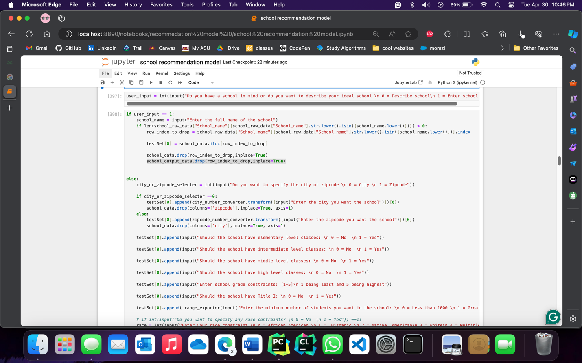

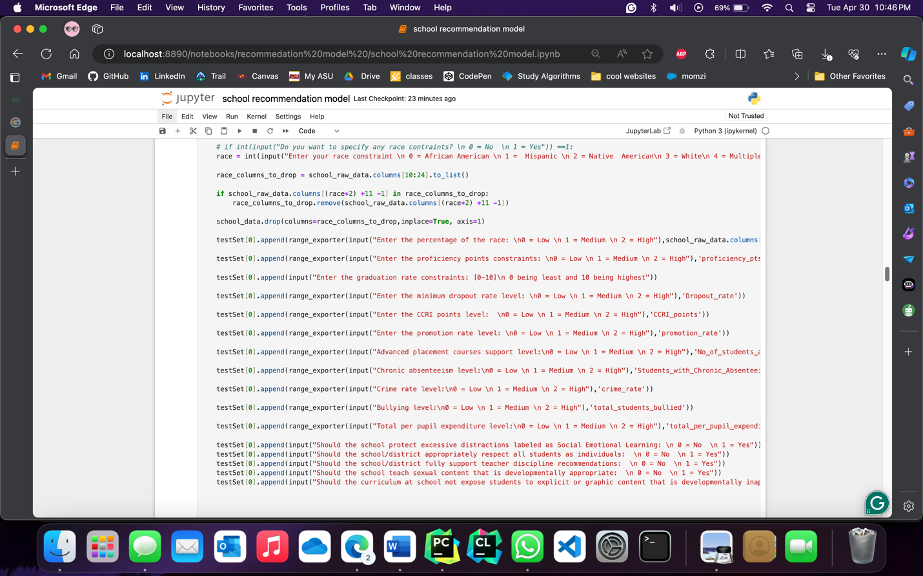

School Selection Criteria Input DataFrame Shape

This code snippet creates a pandas DataFrame called test from the testSet list, which contains user inputs for school selection criteria. The code then attempts to convert the values in the test DataFrame to integers using the astype(int) method. Finally, the code retrieves the shape of the test DataFrame using the shape attribute.

The test DataFrame represents the user inputs for school selection criteria, with each row representing a set of inputs. The shape of the DataFrame indicates the number of rows and columns in the DataFrame.

Code

testSet[0]

test = pd.DataFrame(testSet)

test.astype(int)

test.shape

Image

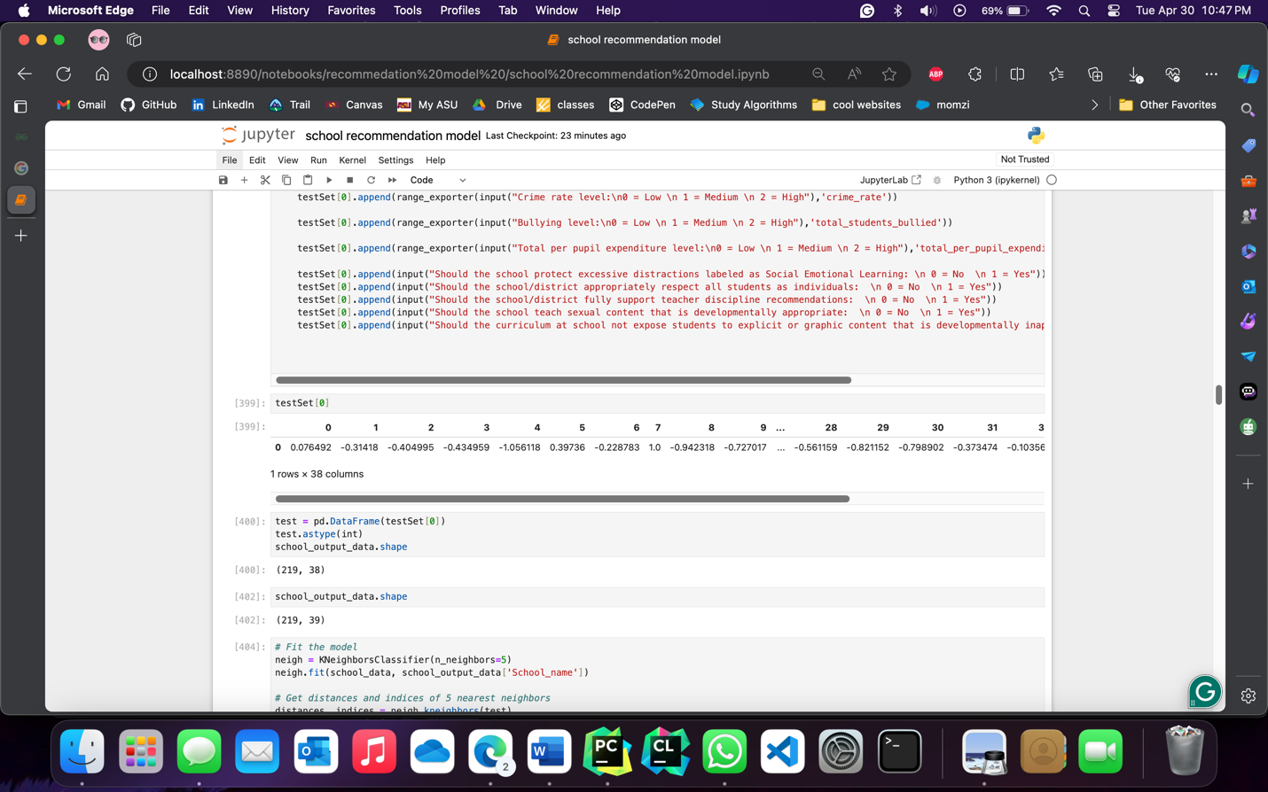

Finding Nearest Schools using K-Nearest Neighbors

Here we fit a K-Nearest Neighbors (KNN) classification model using the `KNeighborsClassifier` algorithm from scikit-learn. The model is trained on `school_data` where the independent variables are stored in `school_data.iloc[:,1:]` and the target variable is `school_data['School_name']`. The model is configured with `n_neighbors=5`, indicating that it will find the 5 nearest neighbors.

Once the model is fitted, the code finds the distances and indices of the 5 nearest neighbors to the `test` data using the `kneighbors` method. It stores the distances in the `distances` variable and the indices of the nearest neighbors in the `indices` variable.

To retrieve the names of the 5 nearest schools, the code initializes an empty list called `output_index` and iterates over the range of 5. It appends the indices of the nearest neighbors from `indices[0]` to `output_index`.

Code

# Fit the model

neigh = KNeighborsClassifier(n_neighbors=5)

neigh.fit(school_data, school_output_data['School_name'])

# Get distances and indices of 5 nearest neighbors

distances, indices = neigh.kneighbors(test)

# Print the names of the 5 nearest schools

output_index = []

for i in range(5):

output_index.append(indices[0][i])

school_raw_data.loc[output_index]

Image

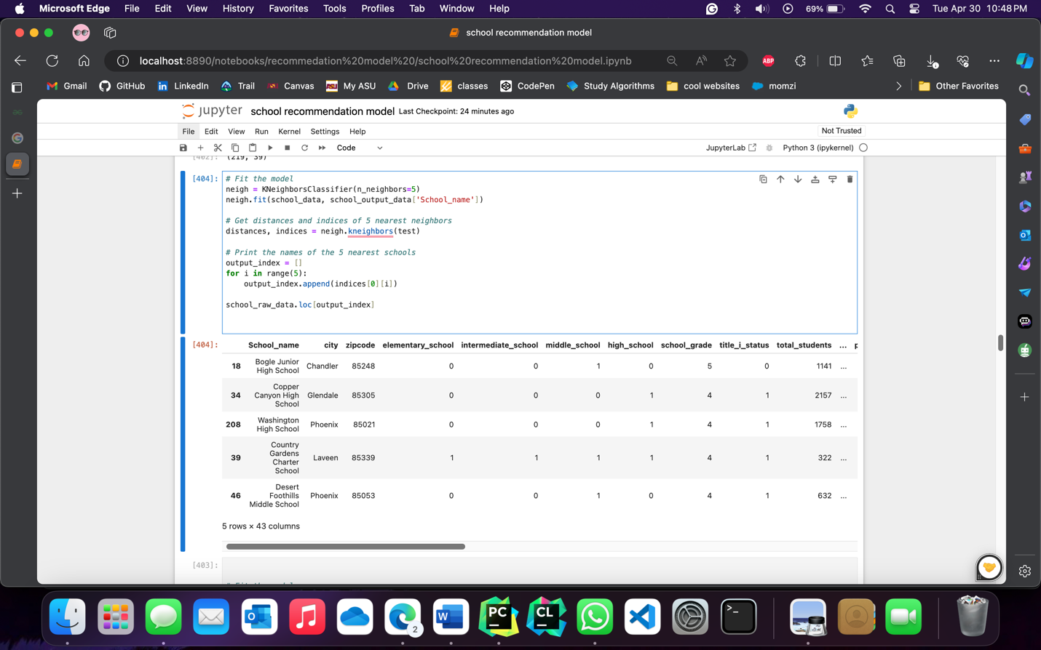

Random Forest Classifier Predictions and School Data Retrieval

To fit a Random Forest Classifier model using the `RandomForestClassifier` algorithm from scikit-learn. The model is trained on `school_data` where the independent variables are stored in `school_data.iloc[:,1:]` and the target variable is `school_data['School_name']`. The model is configured with `n_estimators=5`, indicating the number of decision trees in the forest.

After fitting the model, the code generates predictions from each tree in the forest using a list comprehension. The predictions are stored in the `predictions` list.

To retrieve the corresponding school data for each prediction, the code initializes an empty list called `output_index`. It iterates over the `predictions` list and converts each prediction to an integer using `int(prediction[0])`. The converted prediction is then appended to `output_index`.

Finally, we can now retrieves the school data corresponding to the indices in `output_index` from the `school_raw_data` DataFrame.

Code

# Fit the model

rf = RandomForestClassifier(n_estimators=5)

rf.fit(school_data, school_output_data['School_name'])

# Get a prediction from each tree in the forest

predictions = [tree.predict(test) for tree in rf.estimators_]

# Print the predictions

output_index = []

for prediction in predictions:

output_index.append(int(prediction[0]))

school_raw_data.loc[output_index]

Image

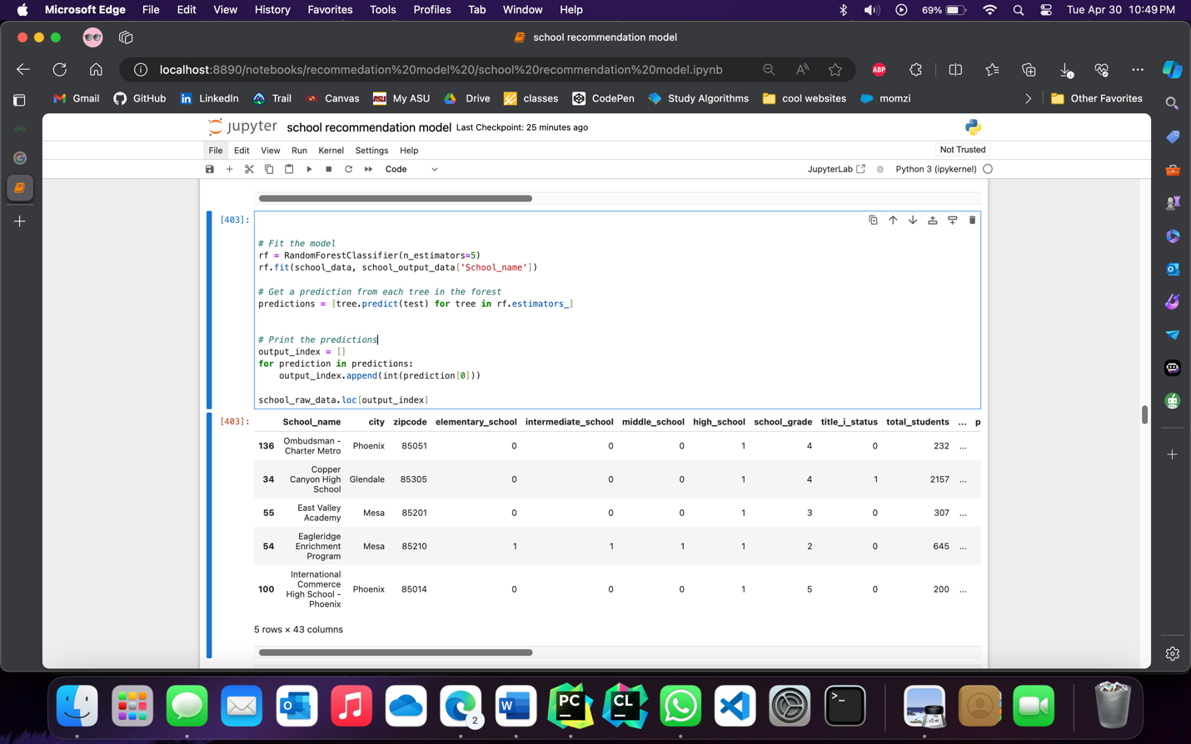

Support Vector Classifier (SVC)

To fit a Support Vector Classifier (SVC) model with probability=True using the SVC algorithm from scikit-learn. The model is trained on school_data where the independent variables are stored in school_data.iloc[:,1:] and the target variable is school_data['School_name'].

After fitting the model, the code obtains class probabilities for the test data using the predict_proba method. The class probabilities are stored in the probabilities array.

To identify the top 5 class indices with the highest probabilities, the code uses np.argsort to sort the probabilities along the second axis in ascending order. It then selects the last 5 columns of the sorted array using [:,-5:].

Next, the code retrieves the class labels from the svc.classes_ attribute and stores them in the classes array.

Finally, the code retrieves the school data from school_raw_data for the schools whose class labels are in the top 5 predicted class labels using the isin method.

Code

# Fit the model with probability=True

svc = SVC(probability=True)

svc.fit(school_data, school_output_data['School_name'])

# Get class probabilities

probabilities = svc.predict_proba(test)

# Get the top 5 class indices

top5_indices = np.argsort(probabilities, axis=1)[:,-5:]

# Get the class labels

classes = svc.classes_

# Get the top 5 class labels

top5_classes = classes[top5_indices]

school_raw_data[school_raw_data['School_name'].isin(top5_classes[0])]

Image

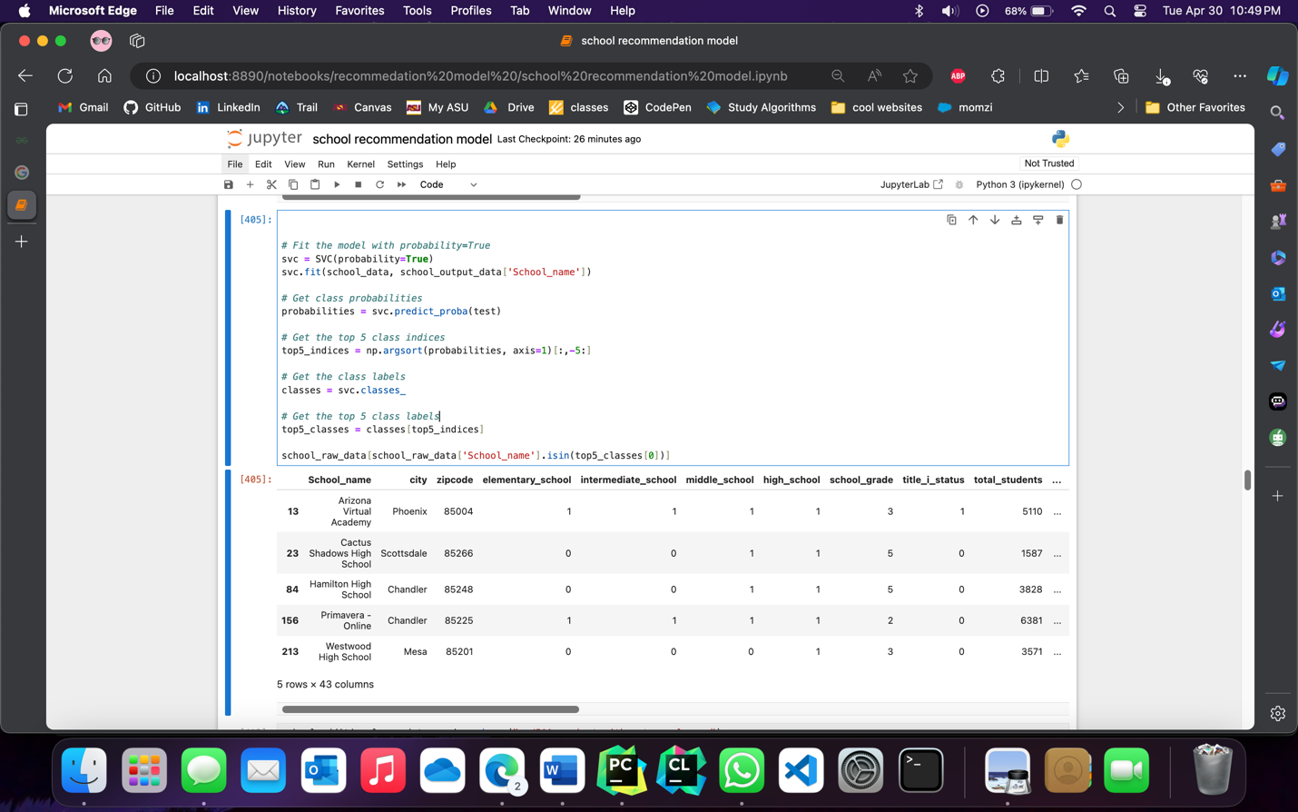

Obtained Results

We used K nearest neighbor, Random Forest, and SVM to display 5 top schools based on the input obtained from the user.

While entering the input the user can either to describe the school with select attributes or give the name of a school based on which the recommendation will be made.

After obtaining the data from the user, it is normalized to provide equal weightage to all attributes and eliminate bias.

Since these are unsupervised clustering models, their performance cannot be measured easily. Yet by theory KNN is supposed to work the best for the given data. The final output per model is selected from the dataset before normalization, for convenience.

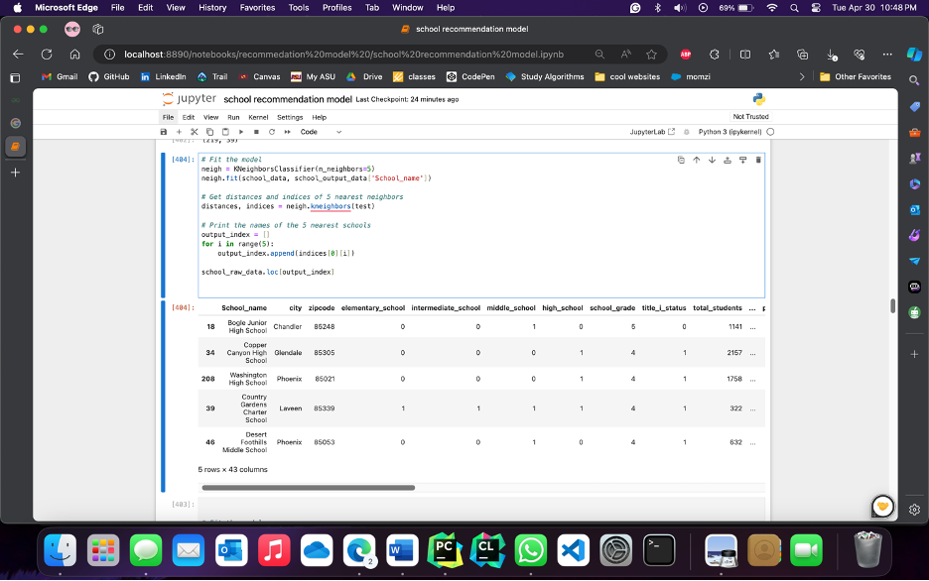

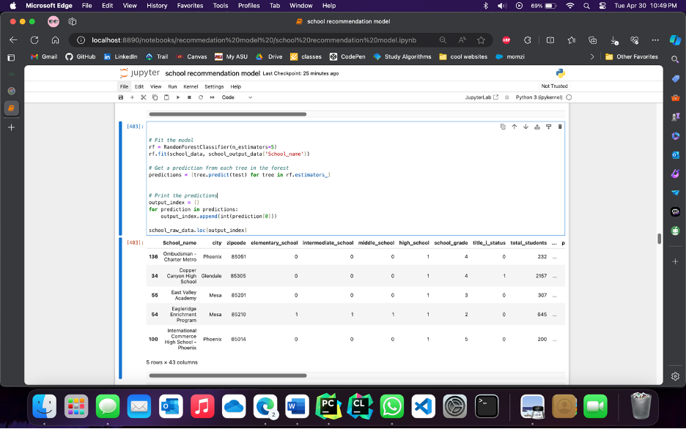

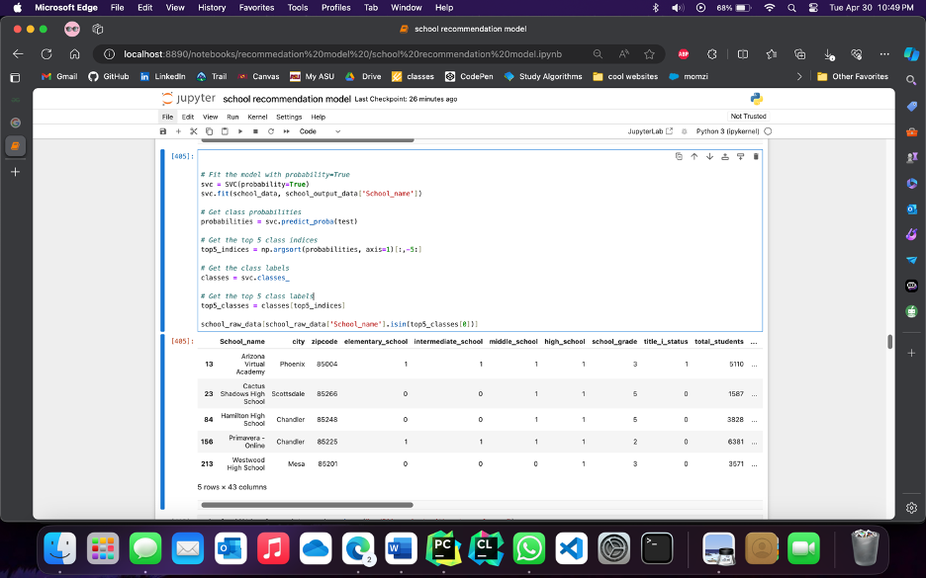

Extra Credit - Plan

**Data Collection**: We will collect additional data from school websites to enhance the existing dataset. This will allow us to gather more comprehensive school information, such as extracurricular activities, facilities, teacher-student ratios, and parent reviews. By incorporating this additional data, we can make more informed recommendations.

**Additional Columns:** We will add the collected data as additional columns to the existing dataset. These new columns will provide valuable insights and contribute to the accuracy of the recommendations.

**Model Re-building:** With the augmented dataset, we will rebuild our machine learning models to incorporate the newly added information. We will use techniques such as feature engineering and model optimization to enhance the performance and predictive power of the models.

**Evaluation:** Since there are no defined methods to evaluate clustering models, we can only measure by the similarity in the attributes in the result sets

Thus, by collecting additional data and incorporating it into our analysis, we expect to improve the accuracy and relevance of the school recommendations. The newly obtained results will reflect these improvements and provide more valuable insights for families seeking suitable public K-12 schools in the Phoenix metropolitan area.

Extra Credit - Data Recollection

Collecting Additional Data from School Websites

We begin by defining a list called "link_of_schools," which contains the URLs of individual school pages on the AZ Report Cards website. These URLs represent high schools and junior high schools in Arizona.

The code utilizes web scraping techniques to extract the desired data from each school's webpage. It employs the BeautifulSoup library to navigate and parse the HTML structure of the school pages.

Once the list of school URLs is defined, the code iterates over each URL using a loop. For each URL, it sends a web request to retrieve the HTML content of the webpage. The returned HTML content is then parsed using BeautifulSoup, allowing the code to extract specific elements and attributes.

We identified the HTML elements and attributes that contain the data by inspecting the structure of the school pages. It then uses BeautifulSoup's find() or find_all() methods, along with appropriate HTML tags and attributes using its Xpath, to locate and extract the desired information.

The obtained additional school data was loaded into a CSV file.

Initial data frame dimensions:

220 rows, 43 columns

Data frame dimensions after data recollection :

220 rows, 473 columns

Code

link_of_schools = ['https://azreportcards.azed.gov//schools/detail/10795',

'https://azreportcards.azed.gov//schools/detail/5462',

'https://azreportcards.azed.gov//schools/detail/5454',

'https://azreportcards.azed.gov//schools/detail/5436',

'https://azreportcards.azed.gov//schools/detail/5431',

'https://azreportcards.azed.gov//schools/detail/5066',

'https://azreportcards.azed.gov//schools/detail/90780',

'https://azreportcards.azed.gov//schools/detail/79454',

'https://azreportcards.azed.gov//schools/detail/90907',

'https://azreportcards.azed.gov//schools/detail/81179',

'https://azreportcards.azed.gov//schools/detail/79982',

'https://azreportcards.azed.gov//schools/detail/91830',

'https://azreportcards.azed.gov//schools/detail/79702',

'https://azreportcards.azed.gov//schools/detail/79705',

'https://azreportcards.azed.gov//schools/detail/5162',

'https://azreportcards.azed.gov//schools/detail/79633',

'https://azreportcards.azed.gov//schools/detail/92270',

'https://azreportcards.azed.gov//schools/detail/89571',

'https://azreportcards.azed.gov//schools/detail/5125',

'https://azreportcards.azed.gov//schools/detail/6249',

'https://azreportcards.azed.gov//schools/detail/85850',

'https://azreportcards.azed.gov//schools/detail/5424',

'https://azreportcards.azed.gov//schools/detail/5014',

'https://azreportcards.azed.gov//schools/detail/5137',

'https://azreportcards.azed.gov//schools/detail/5438',

'https://azreportcards.azed.gov//schools/detail/90124',

'https://azreportcards.azed.gov//schools/detail/5440',

'https://azreportcards.azed.gov//schools/detail/5016',

'https://azreportcards.azed.gov//schools/detail/5439',

'https://azreportcards.azed.gov//schools/detail/78847',

'https://azreportcards.azed.gov//schools/detail/5127',

'https://azreportcards.azed.gov//schools/detail/91282',

'https://azreportcards.azed.gov//schools/detail/5069',

'https://azreportcards.azed.gov//schools/detail/92259',

'https://azreportcards.azed.gov//schools/detail/85810',

'https://azreportcards.azed.gov//schools/detail/79099',

'https://azreportcards.azed.gov//schools/detail/5447',

'https://azreportcards.azed.gov//schools/detail/5067',

'https://azreportcards.azed.gov//schools/detail/5429',

'https://azreportcards.azed.gov//schools/detail/79102',

'https://azreportcards.azed.gov//schools/detail/78813',

'https://azreportcards.azed.gov//schools/detail/79476',

'https://azreportcards.azed.gov//schools/detail/79506',

'https://azreportcards.azed.gov//schools/detail/5161',

'https://azreportcards.azed.gov//schools/detail/5142',

'https://azreportcards.azed.gov//schools/detail/79799',

'https://azreportcards.azed.gov//schools/detail/5250',

'https://azreportcards.azed.gov//schools/detail/78901',

'https://azreportcards.azed.gov//schools/detail/79958',

'https://azreportcards.azed.gov//schools/detail/5070',

'https://azreportcards.azed.gov//schools/detail/5449',

'https://azreportcards.azed.gov//schools/detail/4983',

'https://azreportcards.azed.gov//schools/detail/92892',

'https://azreportcards.azed.gov//schools/detail/5133',

'https://azreportcards.azed.gov//schools/detail/4967',

'https://azreportcards.azed.gov//schools/detail/78932',

'https://azreportcards.azed.gov//schools/detail/87350',

'https://azreportcards.azed.gov//schools/detail/79376',

'https://azreportcards.azed.gov//schools/detail/78900',

'https://azreportcards.azed.gov//schools/detail/5167',

'https://azreportcards.azed.gov//schools/detail/90303',

'https://azreportcards.azed.gov//schools/detail/89778',

'https://azreportcards.azed.gov//schools/detail/4971',

'https://azreportcards.azed.gov//schools/detail/5480',

'https://azreportcards.azed.gov//schools/detail/5019',

'https://azreportcards.azed.gov//schools/detail/5039',

'https://azreportcards.azed.gov//schools/detail/5466',

'https://azreportcards.azed.gov//schools/detail/5426',

'https://azreportcards.azed.gov//schools/detail/92246',

'https://azreportcards.azed.gov//schools/detail/90635',

'https://azreportcards.azed.gov//schools/detail/90999',

'https://azreportcards.azed.gov//schools/detail/91000',

'https://azreportcards.azed.gov//schools/detail/89487',

'https://azreportcards.azed.gov//schools/detail/88300',

'https://azreportcards.azed.gov//schools/detail/92317',

'https://azreportcards.azed.gov//schools/detail/89830',

'https://azreportcards.azed.gov//schools/detail/92732',

'https://azreportcards.azed.gov//schools/detail/91422',

'https://azreportcards.azed.gov//schools/detail/89757',

'https://azreportcards.azed.gov//schools/detail/91156',

'https://azreportcards.azed.gov//schools/detail/80994',

'https://azreportcards.azed.gov//schools/detail/5022',

'https://azreportcards.azed.gov//schools/detail/5433',

'https://azreportcards.azed.gov//schools/detail/5101',

'https://azreportcards.azed.gov//schools/detail/6015',

'https://azreportcards.azed.gov//schools/detail/5509',

'https://azreportcards.azed.gov//schools/detail/92521',

'https://azreportcards.azed.gov//schools/detail/5040',

'https://azreportcards.azed.gov//schools/detail/6006',

'https://azreportcards.azed.gov//schools/detail/79374',

'https://azreportcards.azed.gov//schools/detail/5155',

'https://azreportcards.azed.gov//schools/detail/81042',

'https://azreportcards.azed.gov//schools/detail/81182',

'https://azreportcards.azed.gov//schools/detail/5106',

'https://azreportcards.azed.gov//schools/detail/89791',

'https://azreportcards.azed.gov//schools/detail/5434',

'https://azreportcards.azed.gov//schools/detail/79952',

'https://azreportcards.azed.gov//schools/detail/5530',

'https://azreportcards.azed.gov//schools/detail/10746',

'https://azreportcards.azed.gov//schools/detail/90208',

'https://azreportcards.azed.gov//schools/detail/88232',

'https://azreportcards.azed.gov//schools/detail/79042',

'https://azreportcards.azed.gov//schools/detail/5015',

'https://azreportcards.azed.gov//schools/detail/79113',

'https://azreportcards.azed.gov//schools/detail/92636',

'https://azreportcards.azed.gov//schools/detail/10884',

'https://azreportcards.azed.gov//schools/detail/4970',

'https://azreportcards.azed.gov//schools/detail/80051',

'https://azreportcards.azed.gov//schools/detail/87416',

'https://azreportcards.azed.gov//schools/detail/81102',

'https://azreportcards.azed.gov//schools/detail/88289',

'https://azreportcards.azed.gov//schools/detail/92605',

'https://azreportcards.azed.gov//schools/detail/5446',

'https://azreportcards.azed.gov//schools/detail/5441',

'https://azreportcards.azed.gov//schools/detail/5445',

'https://azreportcards.azed.gov//schools/detail/89593',

'https://azreportcards.azed.gov//schools/detail/78930',

'https://azreportcards.azed.gov//schools/detail/4980',

'https://azreportcards.azed.gov//schools/detail/6007',

'https://azreportcards.azed.gov//schools/detail/5021',

'https://azreportcards.azed.gov//schools/detail/6248',

'https://azreportcards.azed.gov//schools/detail/10847',

'https://azreportcards.azed.gov//schools/detail/80385',

'https://azreportcards.azed.gov//schools/detail/78926',

'https://azreportcards.azed.gov//schools/detail/5430',

'https://azreportcards.azed.gov//schools/detail/5448',

'https://azreportcards.azed.gov//schools/detail/5163',

'https://azreportcards.azed.gov//schools/detail/5259',

'https://azreportcards.azed.gov//schools/detail/79729',

'https://azreportcards.azed.gov//schools/detail/5482',

'https://azreportcards.azed.gov//schools/detail/78883',

'https://azreportcards.azed.gov//schools/detail/5107',

'https://azreportcards.azed.gov//schools/detail/5442',

'https://azreportcards.azed.gov//schools/detail/79456',

'https://azreportcards.azed.gov//schools/detail/91825',

'https://azreportcards.azed.gov//schools/detail/5493',

'https://azreportcards.azed.gov//schools/detail/89440',

'https://azreportcards.azed.gov//schools/detail/78814',

'https://azreportcards.azed.gov//schools/detail/79174',

'https://azreportcards.azed.gov//schools/detail/80026',

'https://azreportcards.azed.gov//schools/detail/10737',

'https://azreportcards.azed.gov//schools/detail/5280',

'https://azreportcards.azed.gov//schools/detail/5263',

'https://azreportcards.azed.gov//schools/detail/79579',

'https://azreportcards.azed.gov//schools/detail/89828',

'https://azreportcards.azed.gov//schools/detail/5105',

'https://azreportcards.azed.gov//schools/detail/89918',

'https://azreportcards.azed.gov//schools/detail/78817',

'https://azreportcards.azed.gov//schools/detail/6231',

'https://azreportcards.azed.gov//schools/detail/5013',

'https://azreportcards.azed.gov//schools/detail/89613',

'https://azreportcards.azed.gov//schools/detail/81175',

'https://azreportcards.azed.gov//schools/detail/88407',

'https://azreportcards.azed.gov//schools/detail/91213',

'https://azreportcards.azed.gov//schools/detail/79621',

'https://azreportcards.azed.gov//schools/detail/79268',

'https://azreportcards.azed.gov//schools/detail/4973',

'https://azreportcards.azed.gov//schools/detail/80006',

'https://azreportcards.azed.gov//schools/detail/79570',

'https://azreportcards.azed.gov//schools/detail/81178',

'https://azreportcards.azed.gov//schools/detail/5141',

'https://azreportcards.azed.gov//schools/detail/92628',

'https://azreportcards.azed.gov//schools/detail/85835',

'https://azreportcards.azed.gov//schools/detail/4984',

'https://azreportcards.azed.gov//schools/detail/4974',

'https://azreportcards.azed.gov//schools/detail/5071',

'https://azreportcards.azed.gov//schools/detail/5068',

'https://azreportcards.azed.gov//schools/detail/90159',

'https://azreportcards.azed.gov//schools/detail/89799',

'https://azreportcards.azed.gov//schools/detail/80317',

'https://azreportcards.azed.gov//schools/detail/79634',

'https://azreportcards.azed.gov//schools/detail/91286',

'https://azreportcards.azed.gov//schools/detail/5500',

'https://azreportcards.azed.gov//schools/detail/10849',

'https://azreportcards.azed.gov//schools/detail/5108',

'https://azreportcards.azed.gov//schools/detail/90134',

'https://azreportcards.azed.gov//schools/detail/5104',

'https://azreportcards.azed.gov//schools/detail/4977',

'https://azreportcards.azed.gov//schools/detail/89908',

'https://azreportcards.azed.gov//schools/detail/78917',

'https://azreportcards.azed.gov//schools/detail/79092',

'https://azreportcards.azed.gov//schools/detail/6350',

'https://azreportcards.azed.gov//schools/detail/79489',

'https://azreportcards.azed.gov//schools/detail/80974',

'https://azreportcards.azed.gov//schools/detail/90639',

'https://azreportcards.azed.gov//schools/detail/78911',

'https://azreportcards.azed.gov//schools/detail/92260',

'https://azreportcards.azed.gov//schools/detail/5443',

'https://azreportcards.azed.gov//schools/detail/80990',

'https://azreportcards.azed.gov//schools/detail/88335',

'https://azreportcards.azed.gov//schools/detail/92044',

'https://azreportcards.azed.gov//schools/detail/4979',

'https://azreportcards.azed.gov//schools/detail/6347',

'https://azreportcards.azed.gov//schools/detail/92645',

'https://azreportcards.azed.gov//schools/detail/5427',

'https://azreportcards.azed.gov//schools/detail/5103',

'https://azreportcards.azed.gov//schools/detail/5017',

'https://azreportcards.azed.gov//schools/detail/92611',

'https://azreportcards.azed.gov//schools/detail/4975',

'https://azreportcards.azed.gov//schools/detail/5444',

'https://azreportcards.azed.gov//schools/detail/5549',

'https://azreportcards.azed.gov//schools/detail/5432',

'https://azreportcards.azed.gov//schools/detail/5452',

'https://azreportcards.azed.gov//schools/detail/85819',

'https://azreportcards.azed.gov//schools/detail/5437',

'https://azreportcards.azed.gov//schools/detail/79111',

'https://azreportcards.azed.gov//schools/detail/88417',

'https://azreportcards.azed.gov//schools/detail/87903',

'https://azreportcards.azed.gov//schools/detail/79177',

'https://azreportcards.azed.gov//schools/detail/92525',

'https://azreportcards.azed.gov//schools/detail/5100',

'https://azreportcards.azed.gov//schools/detail/5428',

'https://azreportcards.azed.gov//schools/detail/6348',

'https://azreportcards.azed.gov//schools/detail/92619',

'https://azreportcards.azed.gov//schools/detail/10801',

'https://azreportcards.azed.gov//schools/detail/5453',

'https://azreportcards.azed.gov//schools/detail/4981',

'https://azreportcards.azed.gov//schools/detail/4987',

'https://azreportcards.azed.gov//schools/detail/91264',

'https://azreportcards.azed.gov//schools/detail/89581',

'https://azreportcards.azed.gov//schools/detail/5110',

'https://azreportcards.azed.gov//schools/detail/81113',

'https://azreportcards.azed.gov//schools/detail/89573']

from selenium import webdriver

from selenium.webdriver.common.by import By

import pandas as pd

from selenium.common.exceptions import NoSuchElementException

options = webdriver.EdgeOptions()

options.add_argument('--headless')

# run browser in headless mode

options.headless = True

driver = webdriver.Edge(options=options)

# load website

for i in link_of_schools[215:]:

url = i

# get the entire website content

driver.get(url)

driver.implicitly_wait(7)

# select elements by class name

# elements = driver.find_elements(By.CLASS_NAME, 'v-table__overflow')

# elements = driver.find_elements_by_xpath("(//*[@class='v-table__overflow'])[1]")

def validator(value):

if value == " " or value == "" or str(value).strip() == "N/A" or str(value).strip() == "" or str(

value).strip() == "No data available" or str(value).strip() == "Declined to Answer":

value = None

elif value == "*":

value = "<10"

return value

african_american = None

asian = None

hispanic = None

native_american = None

white = None

pacific_islander = None

multiple_race = None

african_american_percent = None

asian_percent = None

hispanic_percent = None

native_american_percent = None

white_percent = None

pacific_islander_percent = None

multiple_race_percent = None

school_name = validator(driver.find_element(By.XPATH, '//*[@id="school-overview"]/div[2]/div[4]/div[1]/div').text)

print(school_name)

edu_range = validator(

driver.find_element(By.XPATH, '//*[@id="school-info"]/div[3]/div[1]/div[1]/div/div[2]/div/div/div[1]/div[3]').text)

edu_range = edu_range.replace("Grade ", "")

#print(edu_range)

school_grade = validator(driver.find_element(By.XPATH,

'//*[@id="school-info"]/div[3]/div[1]/div[1]/div/div[2]/div/div/div[6]/div[2]/div[2]/button/div/span').text)

#print(school_name, edu_range, school_grade)

title_i_status = validator(

driver.find_element(By.XPATH, '//*[@id="school-info"]/div[3]/div[1]/div[1]/div/div[2]/div/div/div[4]/div[3]').text)

#print(school_name, edu_range, school_grade, title_i_status)

data_btn = driver.find_element(By.XPATH, '//*[@id="enrollment"]/div[1]/div/div[2]/div/div[1]/div/button[3]')

driver.execute_script("arguments[0].click();", data_btn)

total_students = validator(driver.find_element(By.XPATH,

'//*[@id="enrollment"]/div[1]/div/div[3]/div/div/div[3]/div/div/div/div/table/tbody/tr[1]/td[2]').text)

#print(total_students)

race_table = driver.find_element(By.XPATH, '//*[@id="enrollment"]/div[1]/div/div[3]/div/div/div[3]').text

for i in race_table.split('\n'):

i = i.split(" ")

if i[0] == "African":

african_american = validator(i[2])

african_american_percent = validator(i[3])

elif i[0] == "Hispanic":

hispanic = validator(i[1])

hispanic_percent = validator(i[2])

elif i[0] == "Native":

native_american = validator(i[2])

native_american_percent = validator(i[3])

elif i[0] == "White":

white = validator(i[1])

white_percent = validator(i[2])

elif i[0] == "Multiple":

multiple_race = validator(i[2])

multiple_race_percent = validator(i[3])

elif i[0] == "Asian":

asian = validator(i[1])

asian_percent = validator(i[2])

elif i[0] == "Pacific":

pacific_islander = validator(i[2])

pacific_islander_percent = validator(i[3])

#print(african_american, african_american_percent)

#print(hispanic, hispanic_percent)

#print(native_american, native_american_percent)

#print(white, white_percent)

#print(multiple_race, multiple_race_percent)

#print(asian, asian_percent)

#print(pacific_islander, pacific_islander_percent)

try:

proficiency_pts = validator(driver.find_element(By.XPATH,'//*[@id="assessmentResults"]/div[1]/div/div[5]/div/div/div[4]/div[2]/div/div/div/div/table/tbody/tr/td[2]').text)

except NoSuchElementException:

proficiency_pts = None

try:

Grad_Rate_pts = validator(driver.find_element(By.XPATH,'//*[@id="entitygraduationrate"]/div[1]/div/div[3]/div/div[3]/div/div/div/table/tbody/tr/td[2]').text)

except NoSuchElementException:

Grad_Rate_pts = None

try:

data_btn = driver.find_element(By.XPATH, '//*[@id="entitydropoutrate"]/div[1]/div/div[2]/div/button[3]')

driver.execute_script("arguments[0].click();", data_btn)

Dropout_rate = validator(driver.find_element(By.XPATH,

'//*[@id="entitydropoutrate"]/div[1]/div/div[3]/div/div[1]/div/div/div/div/div/table/tbody/tr[1]/td[2]').text)

except NoSuchElementException:

Dropout_rate = None

try:

CCRI_points = validator(

driver.find_element(By.XPATH, '//*[@id="ccripoints"]/div/div/div[2]/div/div/table/tbody/tr/td[2]').text)

#print(CCRI_points)

except NoSuchElementException:

CCRI_points = None

data_btn = driver.find_element(By.XPATH, '//*[@id="entityendofyearpromotion"]/div[1]/div/div[3]/div/button[2]')

driver.execute_script("arguments[0].click();", data_btn)

promotion_rate = validator(driver.find_element(By.XPATH,

'//*[@id="entityendofyearpromotion"]/div[1]/div/div[4]/div/div[1]/div/div/div/div/div/table/tbody/tr[1]/td[2]').text)

#print(promotion_rate)

try:

No_of_students_adv_placement_course = validator(driver.find_element(By.XPATH,'//*[@id="civil-rights"]/div/div[1]/div[2]/div/div[1]/div[2]/div/div/table/tbody/tr[1]/td[2]/div').text )

Students_with_Chronic_Absenteeism = validator(driver.find_element(By.XPATH,'//*[@id="civil-rights"]/div/div[1]/div[2]/div/div[1]/div[2]/div/div/table/tbody/tr[2]/td[2]/div').text)

crime_rate = validator(driver.find_element(By.XPATH,'//*[@id="civil-rights"]/div/div[1]/div[2]/div/div[1]/div[2]/div/div/table/tbody/tr[3]/td[2]/div').text )

total_students_bullied = validator(driver.find_element(By.XPATH,'//*[@id="civil-rights"]/div/div[1]/div[2]/div/div[1]/div[2]/div/div/table/tbody/tr[4]/td[2]/div').text )

except NoSuchElementException:

No_of_students_adv_placement_course = None

Students_with_Chronic_Absenteeism = None

crime_rate = None

total_students_bullied = None

try:

personnel_federal_expenditure = validator(validator(driver.find_element(By.XPATH,'//*[@id="Per-Pupil-Expenditure"]/div[2]/div[4]/div[2]/div/div/div/div/div/div/table/tbody/tr/td[1]').text))

#print(personnel_federal_expenditure)

personnel_state_and_local_expenditure = validator(validator(driver.find_element(By.XPATH,'//*[@id="Per-Pupil-Expenditure"]/div[2]/div[4]/div[2]/div/div/div/div/div/div/table/tbody/tr/td[2]').text))

#print(personnel_state_and_local_expenditure)

non_personnel_federal_expenditure = validator(validator(driver.find_element(By.XPATH,'//*[@id="Per-Pupil-Expenditure"]/div[2]/div[4]/div[2]/div/div/div/div/div/div/table/tbody/tr/td[3]').text))

#print(non_personnel_federal_expenditure)

non_personnel_state_and_local_expenditure = validator(validator(driver.find_element(By.XPATH,'//*[@id="Per-Pupil-Expenditure"]/div[2]/div[4]/div[2]/div/div/div/div/div/div/table/tbody/tr/td[4]').text))

#print(non_personnel_state_and_local_expenditure)

total_per_pupil_expenditure = validator(validator(driver.find_element(By.XPATH,'//*[@id="Per-Pupil-Expenditure"]/div[2]/div[4]/div[2]/div/div/div/div/div/div/table/tbody/tr/td[5]').text))

#print(total_per_pupil_expenditure)

except NoSuchElementException:

personnel_federal_expenditure = None

personnel_state_and_local_expenditure = None

non_personnel_federal_expenditure = None

non_personnel_state_and_local_expenditure = None

total_per_pupil_expenditure = None

data_btn = driver.find_element(By.XPATH,

'//*[@id="edorg-characteristics"]/div/div[2]/div/div[2]/div/div[1]/div[1]/article/div/div[1]/div[3]/i')

driver.execute_script("arguments[0].click();", data_btn)

awards_and_recognitions = driver.find_element(By.XPATH,

'//*[@id="edorg-characteristics"]/div/div[2]/div/div[2]/div/div[1]/div[1]/article/div/div[2]/section/div/div/div').text.split(

'\n')

if awards_and_recognitions == ['']:

data_btn = driver.find_element(By.XPATH,

'//*[@id="edorg-characteristics"]/div/div[2]/div/div[2]/div/div[1]/div[1]/article/div/div[1]/div[3]/i')

driver.execute_script("arguments[0].click();", data_btn)

awards_and_recognitions = driver.find_element(By.XPATH,

'//*[@id="edorg-characteristics"]/div/div[2]/div/div[2]/div/div[1]/div[1]/article/div/div[2]/section/div/div/div').text.split(

'\n')

#print(awards_and_recognitions)

data_btn = driver.find_element(By.XPATH,

'//*[@id="edorg-characteristics"]/div/div[2]/div/div[2]/div/div[2]/div[1]/article/div/div[1]/div[3]/i')

driver.execute_script("arguments[0].click();", data_btn)

academic_offerings = driver.find_element(By.XPATH,

'//*[@id="edorg-characteristics"]/div/div[2]/div/div[2]/div/div[2]/div[1]/article/div/div[2]/section/div/div/div').text.split(

'\n')

#

if academic_offerings == ['']:

data_btn = driver.find_element(By.XPATH,

'//*[@id="edorg-characteristics"]/div/div[2]/div/div[2]/div/div[2]/div[1]/article/div/div[1]/div[3]/i')

driver.execute_script("arguments[0].click();", data_btn)

academic_offerings = driver.find_element(By.XPATH,

'//*[@id="edorg-characteristics"]/div/div[2]/div/div[2]/div/div[2]/div[1]/article/div/div[2]/section/div/div/div').text.split(

'\n')

#print(academic_offerings)

data_btn = driver.find_element(By.XPATH,

'//*[@id="edorg-characteristics"]/div/div[2]/div/div[2]/div/div[3]/div[1]/article/div/div[1]/div[3]/i')

driver.execute_script("arguments[0].click();", data_btn)

sports_facilities = driver.find_element(By.XPATH,

'//*[@id="edorg-characteristics"]/div/div[2]/div/div[2]/div/div[3]/div[1]/article/div/div[2]/section/div/div/div').text.split(

'\n')

if sports_facilities == ['']:

data_btn = driver.find_element(By.XPATH,

'//*[@id="edorg-characteristics"]/div/div[2]/div/div[2]/div/div[3]/div[1]/article/div/div[1]/div[3]/i')

driver.execute_script("arguments[0].click();", data_btn)

sports_facilities = driver.find_element(By.XPATH,

'//*[@id="edorg-characteristics"]/div/div[2]/div/div[2]/div/div[3]/div[1]/article/div/div[2]/section/div/div/div').text.split(

'\n')

#print(sports_facilities)

data_btn = driver.find_element(By.XPATH,

'//*[@id="edorg-characteristics"]/div/div[2]/div/div[2]/div/div[4]/div[1]/article/div/div[1]/div[3]/i')

driver.execute_script("arguments[0].click();", data_btn)

music_facilities = driver.find_element(By.XPATH,

'//*[@id="edorg-characteristics"]/div/div[2]/div/div[2]/div/div[4]/div[1]/article/div/div[2]/section/div/div/div').text.split(

'\n')

if music_facilities == ['']:

data_btn = driver.find_element(By.XPATH,

'//*[@id="edorg-characteristics"]/div/div[2]/div/div[2]/div/div[4]/div[1]/article/div/div[1]/div[3]/i')

driver.execute_script("arguments[0].click();", data_btn)

music_facilities = driver.find_element(By.XPATH,

'//*[@id="edorg-characteristics"]/div/div[2]/div/div[2]/div/div[4]/div[1]/article/div/div[2]/section/div/div/div').text.split(

'\n')

#print(music_facilities)

data_btn = driver.find_element(By.XPATH,

'//*[@id="edorg-characteristics"]/div/div[2]/div/div[2]/div/div[5]/div[1]/article/div/div[1]/div[3]/i')

driver.execute_script("arguments[0].click();", data_btn)

after_school_opportunities = (driver.find_element(By.XPATH,

'//*[@id="edorg-characteristics"]/div/div[2]/div/div[2]/div/div[5]/div[1]/article/div/div[2]/section/div/div/div')

.text.split('\n'))

if after_school_opportunities == ['']:

data_btn = driver.find_element(By.XPATH,

'//*[@id="edorg-characteristics"]/div/div[2]/div/div[2]/div/div[5]/div[1]/article/div/div[1]/div[3]/i')

driver.execute_script("arguments[0].click();", data_btn)

after_school_opportunities = (driver.find_element(By.XPATH,

'//*[@id="edorg-characteristics"]/div/div[2]/div/div[2]/div/div[5]/div[1]/article/div/div[2]/section/div/div/div')

.text.split('\n'))

#print(after_school_opportunities)

data_btn = driver.find_element(By.XPATH,

'//*[@id="edorg-characteristics"]/div/div[2]/div/div[2]/div/div[6]/div[1]/article/div/div[1]/div[3]/i')

driver.execute_script("arguments[0].click();", data_btn)

other_facilities = (driver.find_element(By.XPATH,

'//*[@id="edorg-characteristics"]/div/div[2]/div/div[2]/div/div[6]/div[1]/article/div/div[2]/section/div/div/div').text.split(

'\n'))

if other_facilities == ['']:

data_btn = driver.find_element(By.XPATH,

'//*[@id="edorg-characteristics"]/div/div[2]/div/div[2]/div/div[6]/div[1]/article/div/div[1]/div[3]/i')

driver.execute_script("arguments[0].click();", data_btn)

other_facilities = (driver.find_element(By.XPATH,

'//*[@id="edorg-characteristics"]/div/div[2]/div/div[2]/div/div[6]/div[1]/article/div/div[2]/section/div/div/div').text.split(

'\n'))

#print(other_facilities)

data_btn = driver.find_element(By.XPATH,

'//*[@id="edorg-characteristics"]/div/div[2]/div/div[2]/div/div[7]/div[1]/article/div/div[1]/div[3]/i')

driver.execute_script("arguments[0].click();", data_btn)

student_services = (driver.find_element(By.XPATH,

'//*[@id="edorg-characteristics"]/div/div[2]/div/div[2]/div/div[7]/div[1]/article/div/div[2]/section/div/div/div').text.split(

'\n'))

if student_services == ['']:

data_btn = driver.find_element(By.XPATH,

'//*[@id="edorg-characteristics"]/div/div[2]/div/div[2]/div/div[7]/div[1]/article/div/div[1]/div[3]/i')

driver.execute_script("arguments[0].click();", data_btn)

student_services = (driver.find_element(By.XPATH,

'//*[@id="edorg-characteristics"]/div/div[2]/div/div[2]/div/div[7]/div[1]/article/div/div[2]/section/div/div/div').text.split(

'\n'))

#print(student_services)

try:

acad_focus_1 =validator(driver.find_element(By.XPATH,'//*[@id="edorg-characteristics"]/div/div[2]/div/div[2]/div[3]/div/div[2]/div/table/tbody/tr[1]/td[2]').text)

acad_focus_2 =validator(driver.find_element(By.XPATH,'//*[@id="edorg-characteristics"]/div/div[2]/div/div[2]/div[3]/div/div[2]/div/table/tbody/tr[2]/td[2]').text)

acad_focus_3 =validator(driver.find_element(By.XPATH,'//*[@id="edorg-characteristics"]/div/div[2]/div/div[2]/div[3]/div/div[2]/div/table/tbody/tr[3]/td[2]').text)

acad_focus_4 =validator(driver.find_element(By.XPATH,'//*[@id="edorg-characteristics"]/div/div[2]/div/div[2]/div[3]/div/div[2]/div/table/tbody/tr[4]/td[2]').text)

acad_focus_5 =validator(driver.find_element(By.XPATH,'//*[@id="edorg-characteristics"]/div/div[2]/div/div[2]/div[3]/div/div[2]/div/table/tbody/tr[5]/td[2]').text)

except NoSuchElementException:

acad_focus_1 = None

acad_focus_2 = None

acad_focus_3 = None

acad_focus_4 = None

acad_focus_5 = None

additional_school_data = pd.DataFrame(

[[school_name, edu_range, school_grade, title_i_status, total_students, african_american, african_american_percent,

hispanic, hispanic_percent,

native_american, native_american_percent,

white, white_percent,

multiple_race, multiple_race_percent,

asian, asian_percent,

pacific_islander, pacific_islander_percent, proficiency_pts, Grad_Rate_pts, Dropout_rate, CCRI_points,

promotion_rate, No_of_students_adv_placement_course, Students_with_Chronic_Absenteeism, crime_rate,

total_students_bullied, personnel_federal_expenditure, personnel_state_and_local_expenditure,

non_personnel_federal_expenditure, non_personnel_state_and_local_expenditure, total_per_pupil_expenditure,

awards_and_recognitions, academic_offerings, sports_facilities, music_facilities, after_school_opportunities,

other_facilities, student_services, acad_focus_1, acad_focus_2, acad_focus_3, acad_focus_4, acad_focus_5]],

columns=['school_name', 'edu_range', 'school_grade', 'title_i_status',

'total_students', 'african_american', 'african_american_percent',

'hispanic', 'hispanic_percent',

'native_american', 'native_american_percent',

'white', 'white_percent',

'multiple_race', 'multiple_race_percent',

'asian', 'asian_percent',

'pacific_islander', 'pacific_islander_percent', 'proficiency_pts', 'Grad_Rate_pts', 'Dropout_rate',

'CCRI_points', 'promotion_rate', 'No_of_students_adv_placement_course',

'Students_with_Chronic_Absenteeism', 'crime_rate', 'total_students_bullied',

'personnel_federal_expenditure', 'personnel_state_and_local_expenditure',

'non_personnel_federal_expenditure', 'non_personnel_state_and_local_expenditure',

'total_per_pupil_expenditure', 'awards_and_recognitions', 'academic_offerings', 'sports_facilities',

'music_facilities', 'after_school_opportunities', 'other_facilities', 'student_services', 'acad_focus_1',

'acad_focus_2', 'acad_focus_3', 'acad_focus_4', 'acad_focus_5'])

additional_school_data.to_csv('school_data_3.csv', mode='a', index=False, header=False)

Image

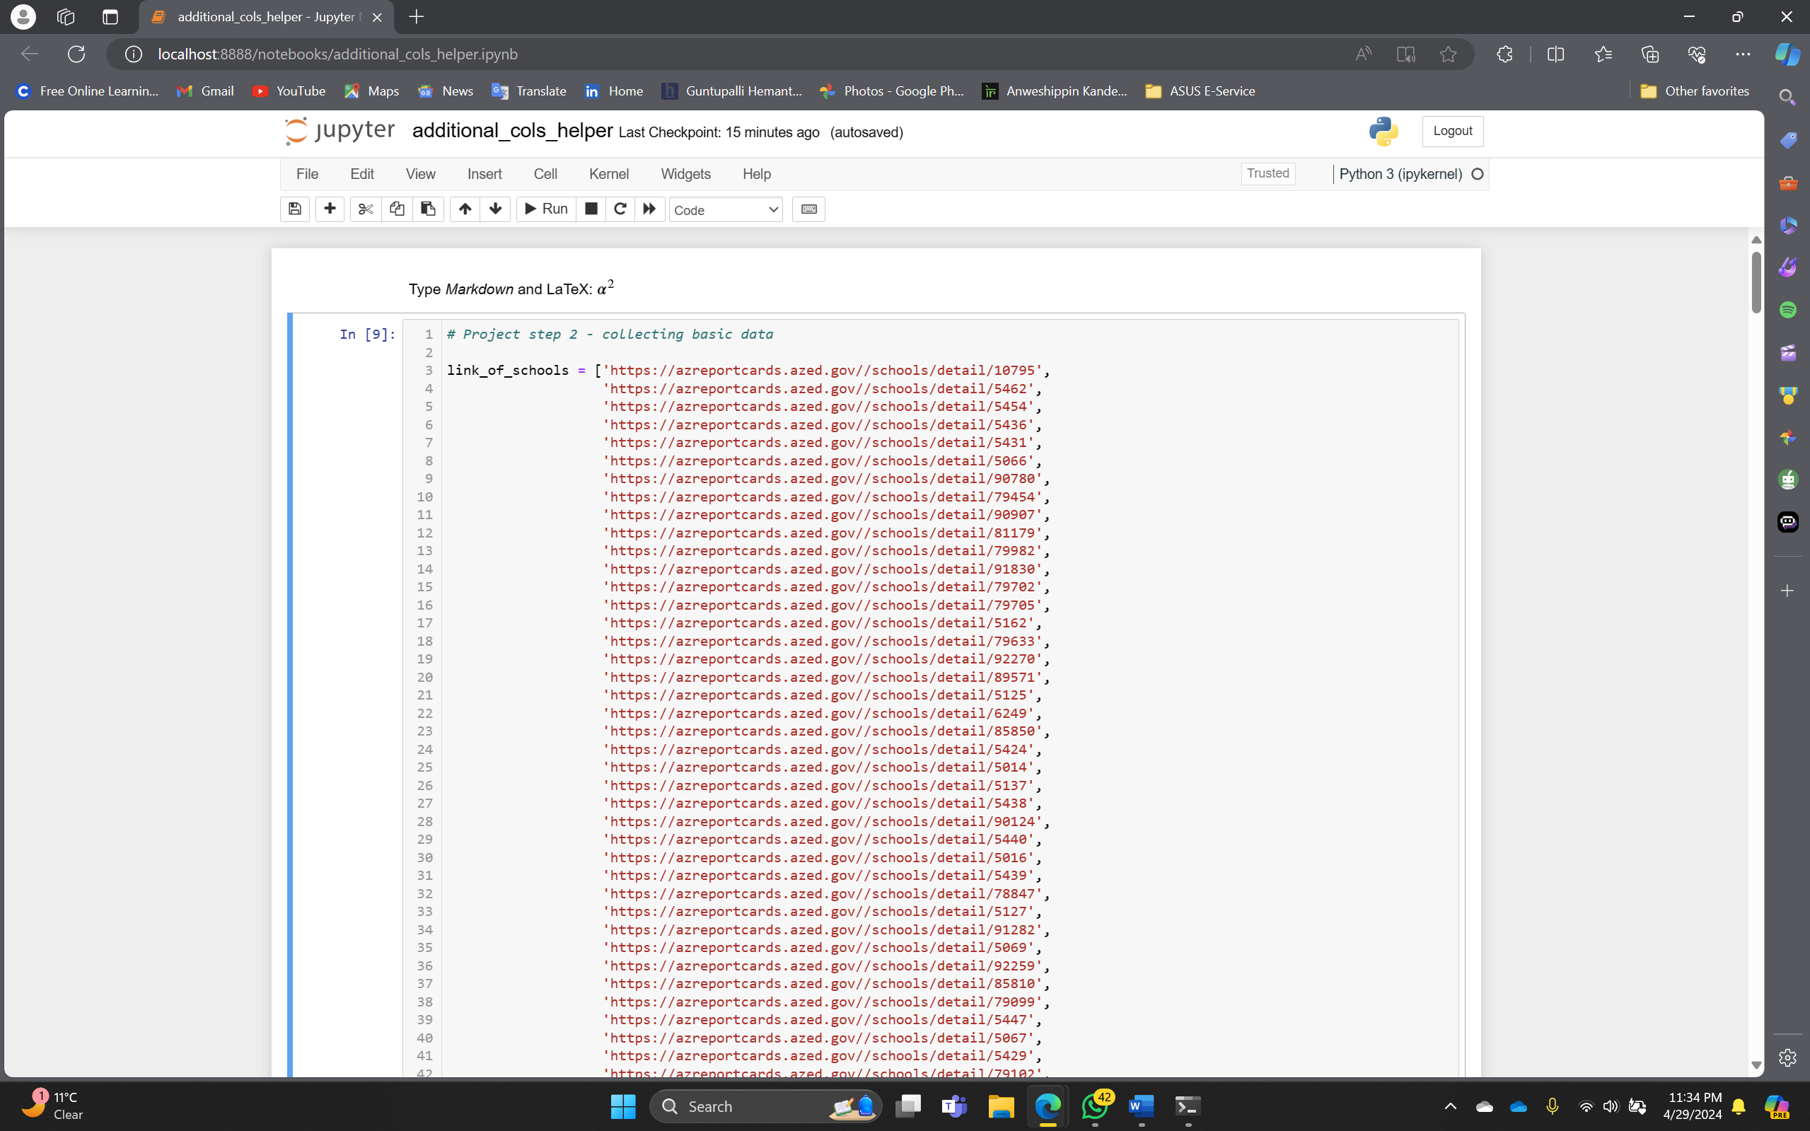

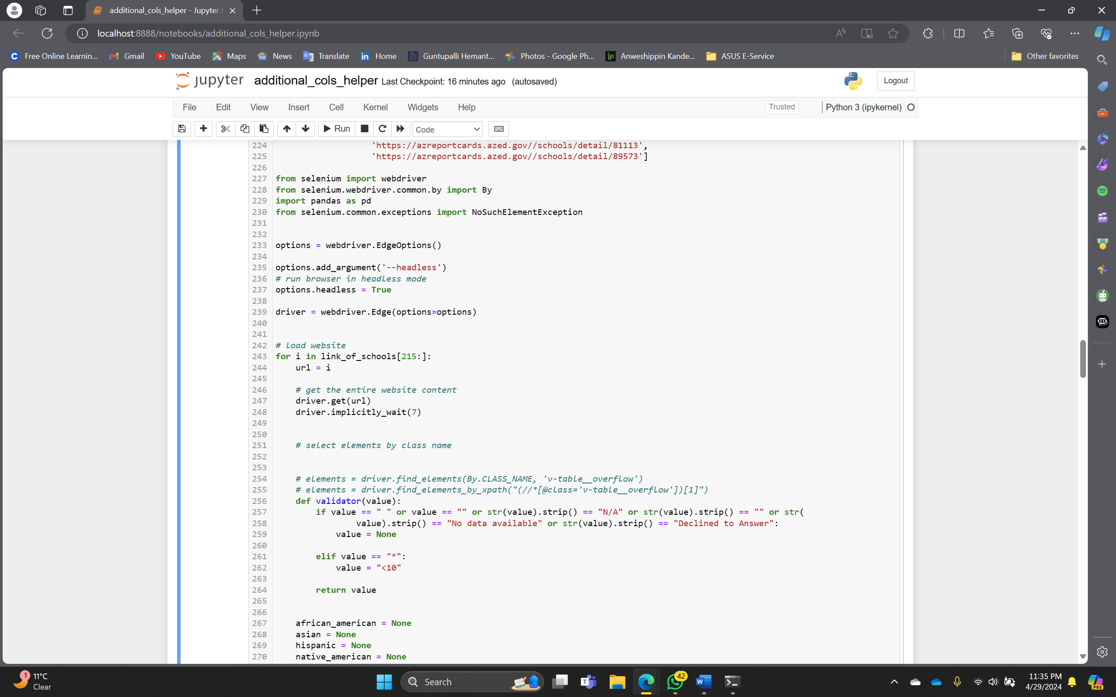

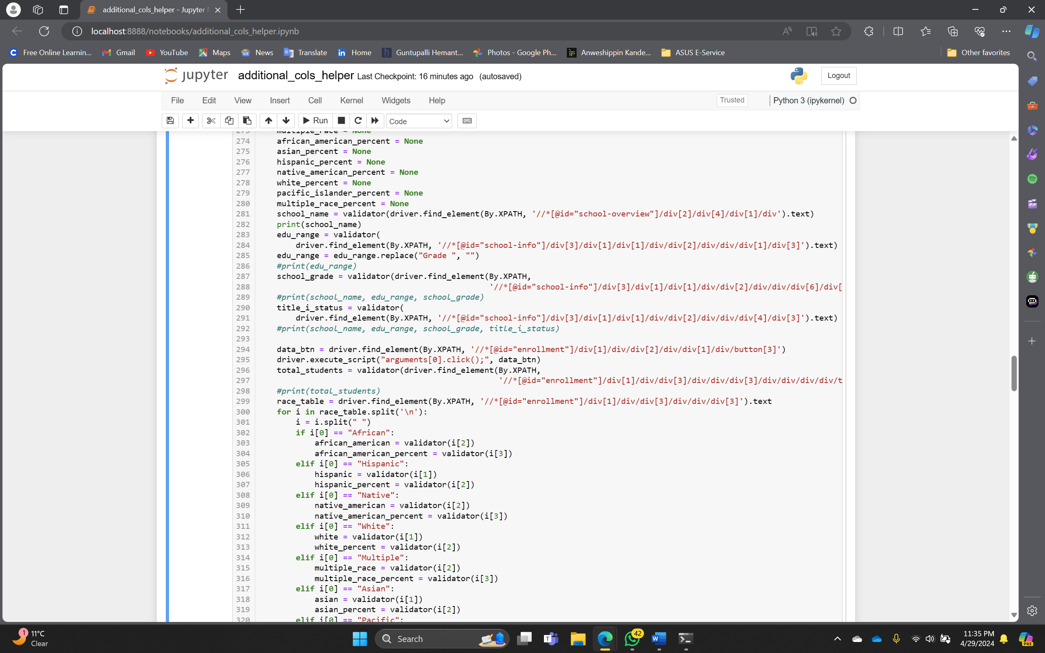

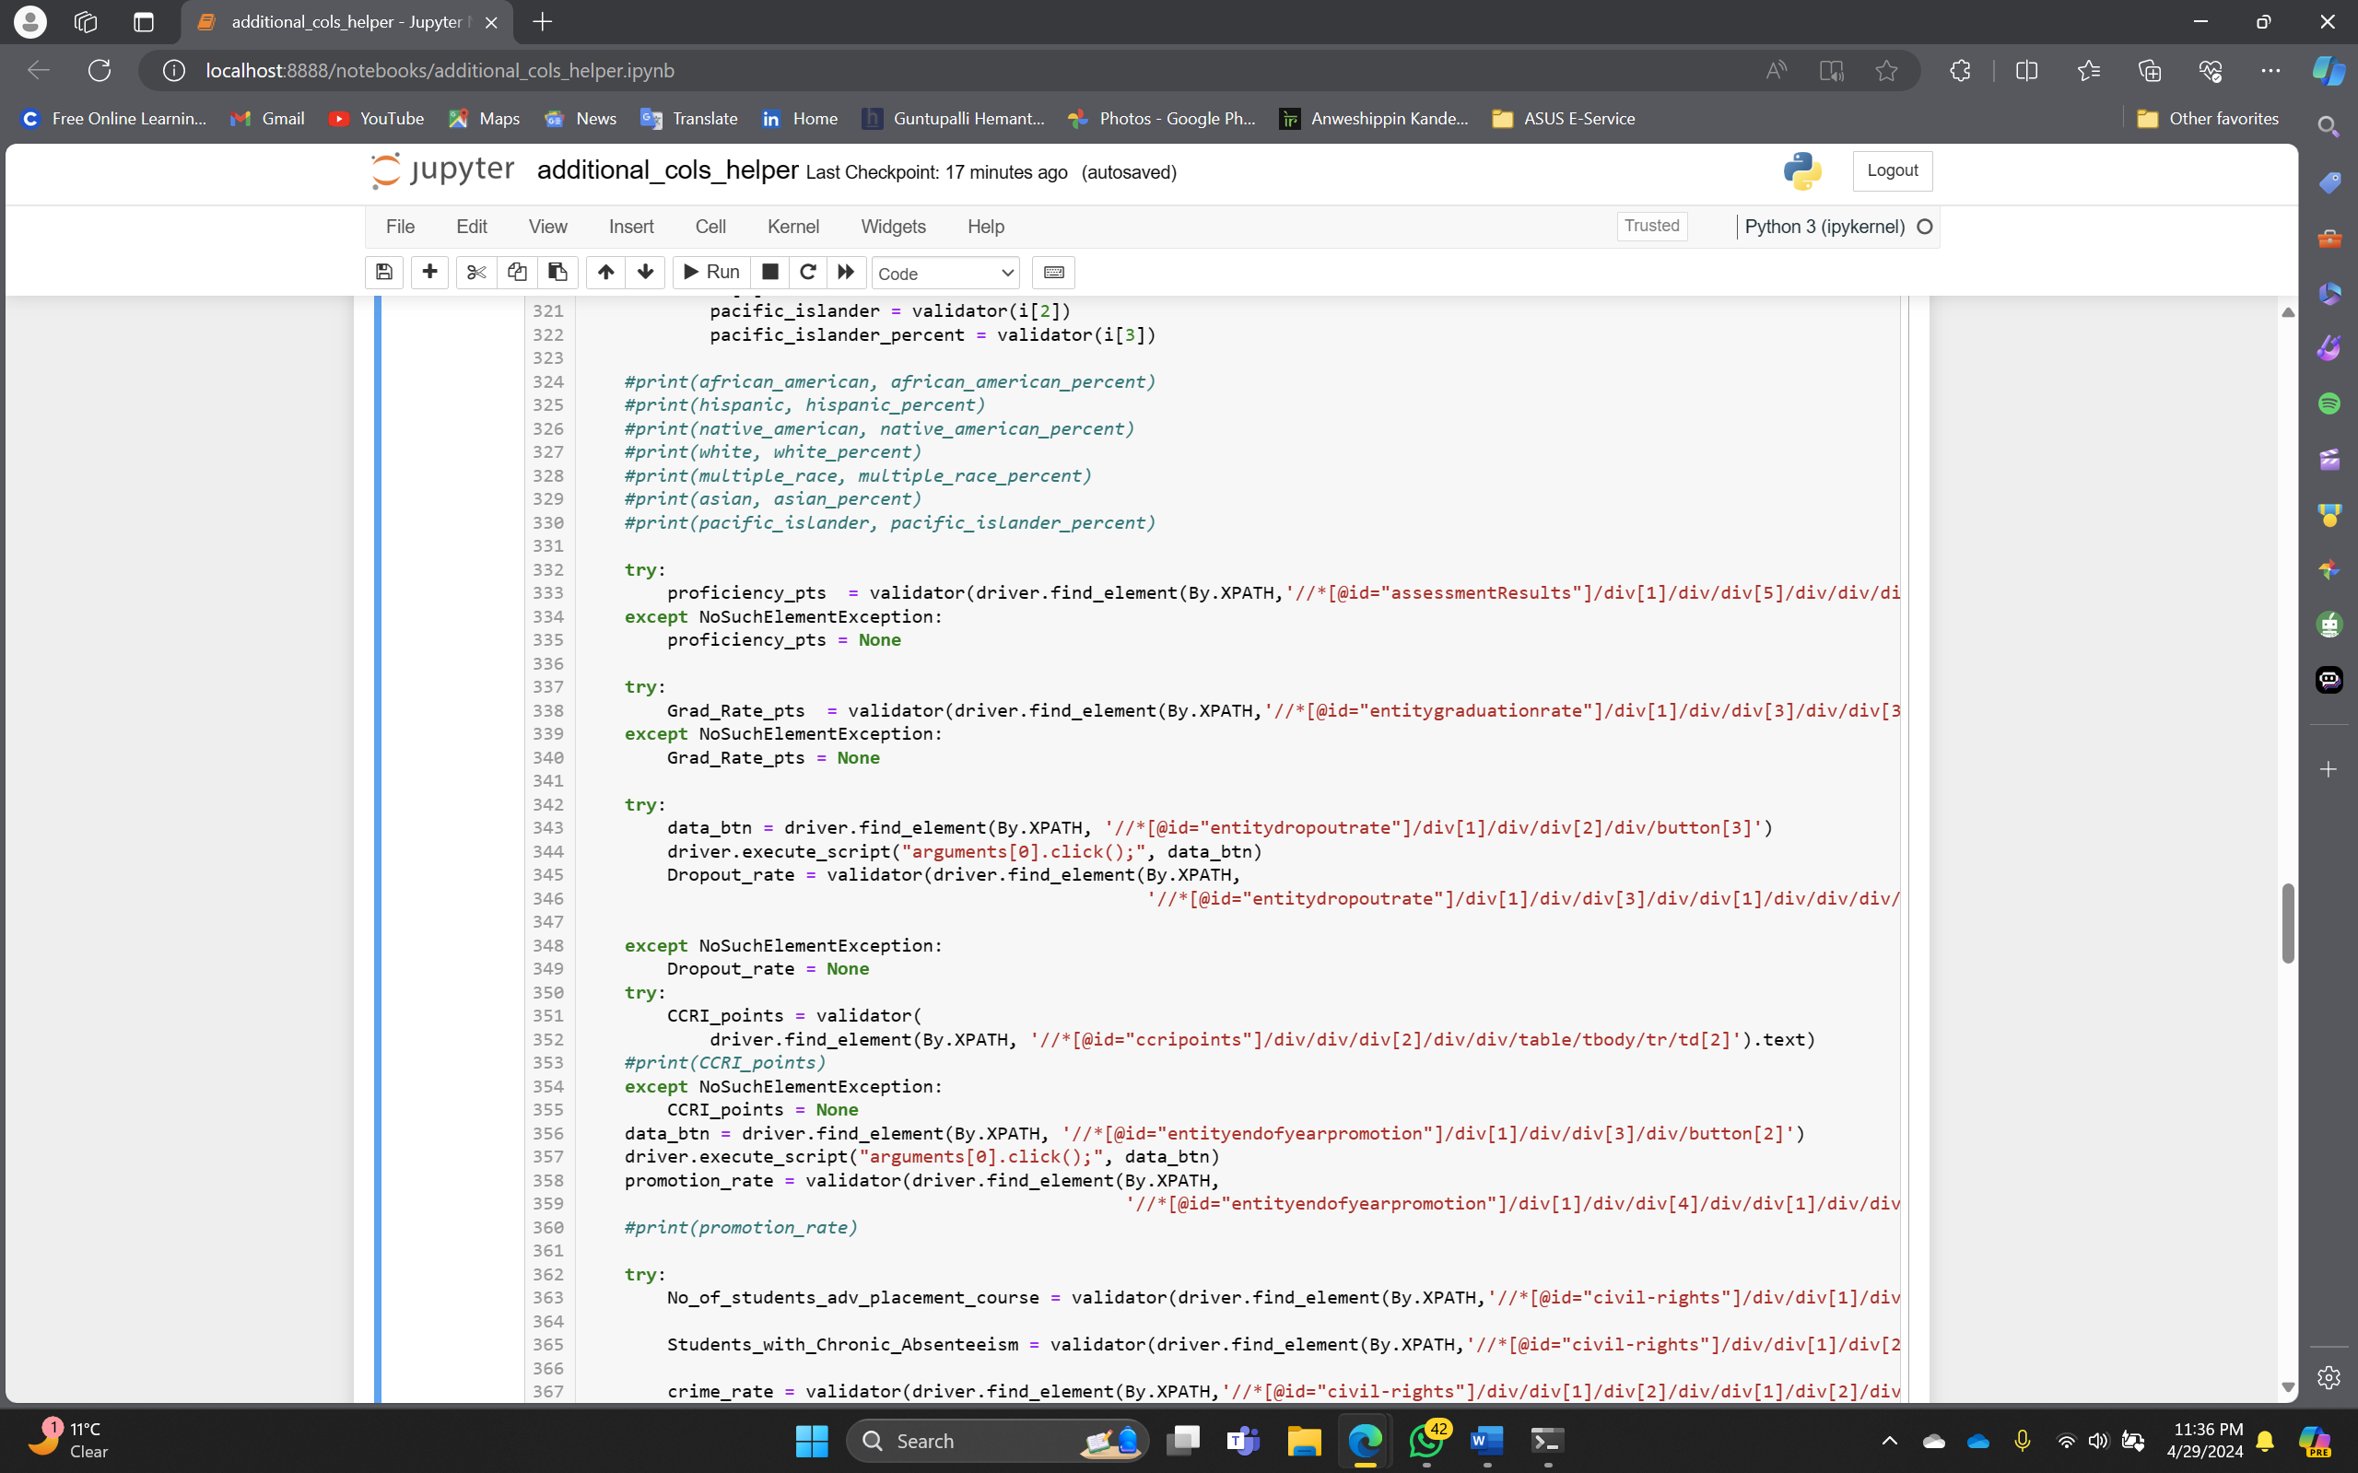

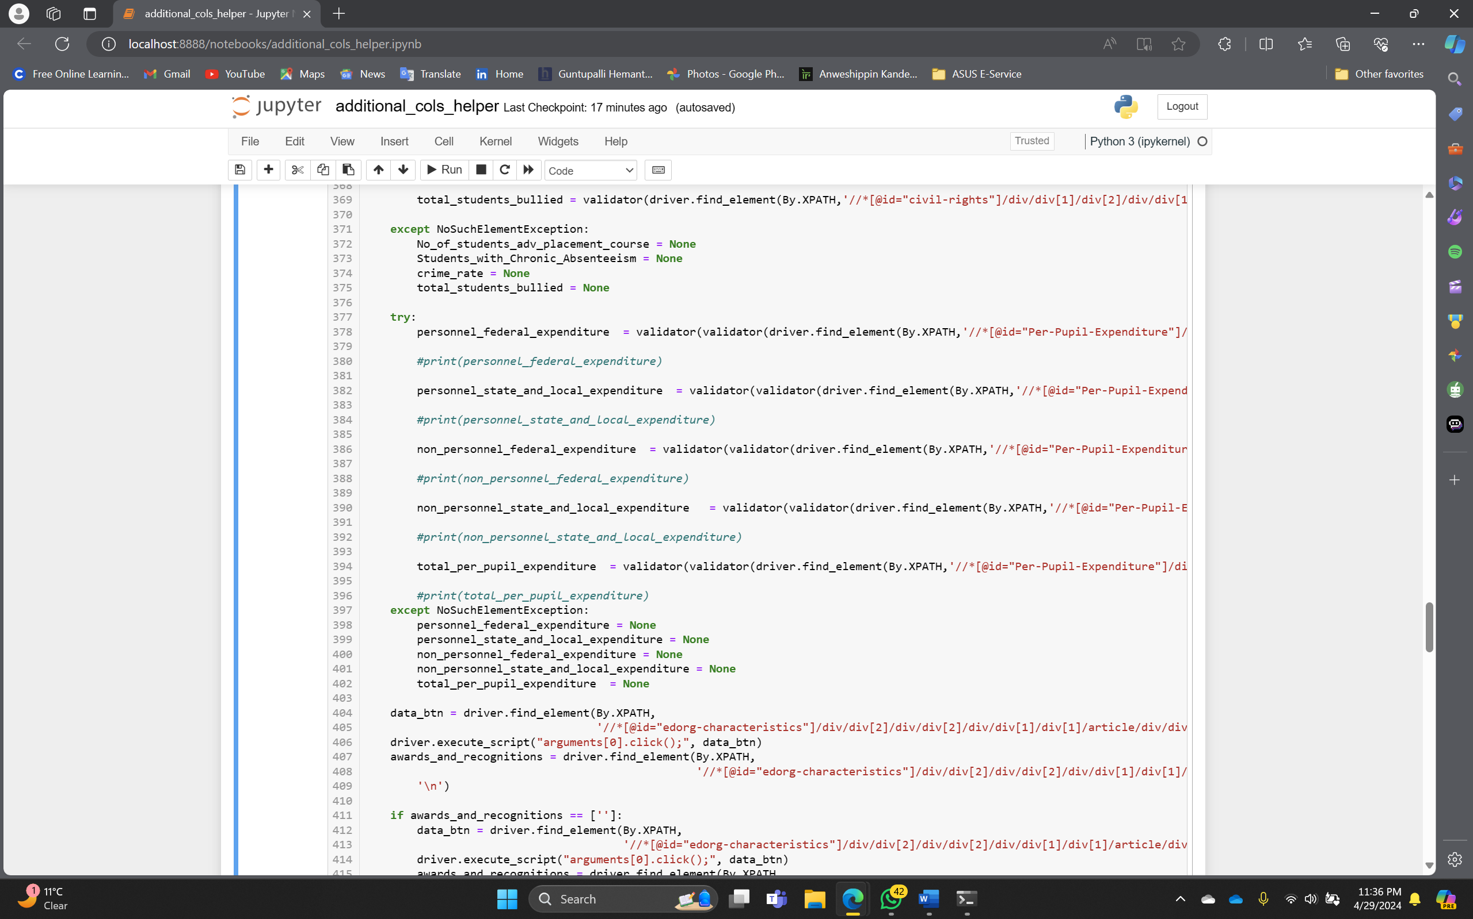

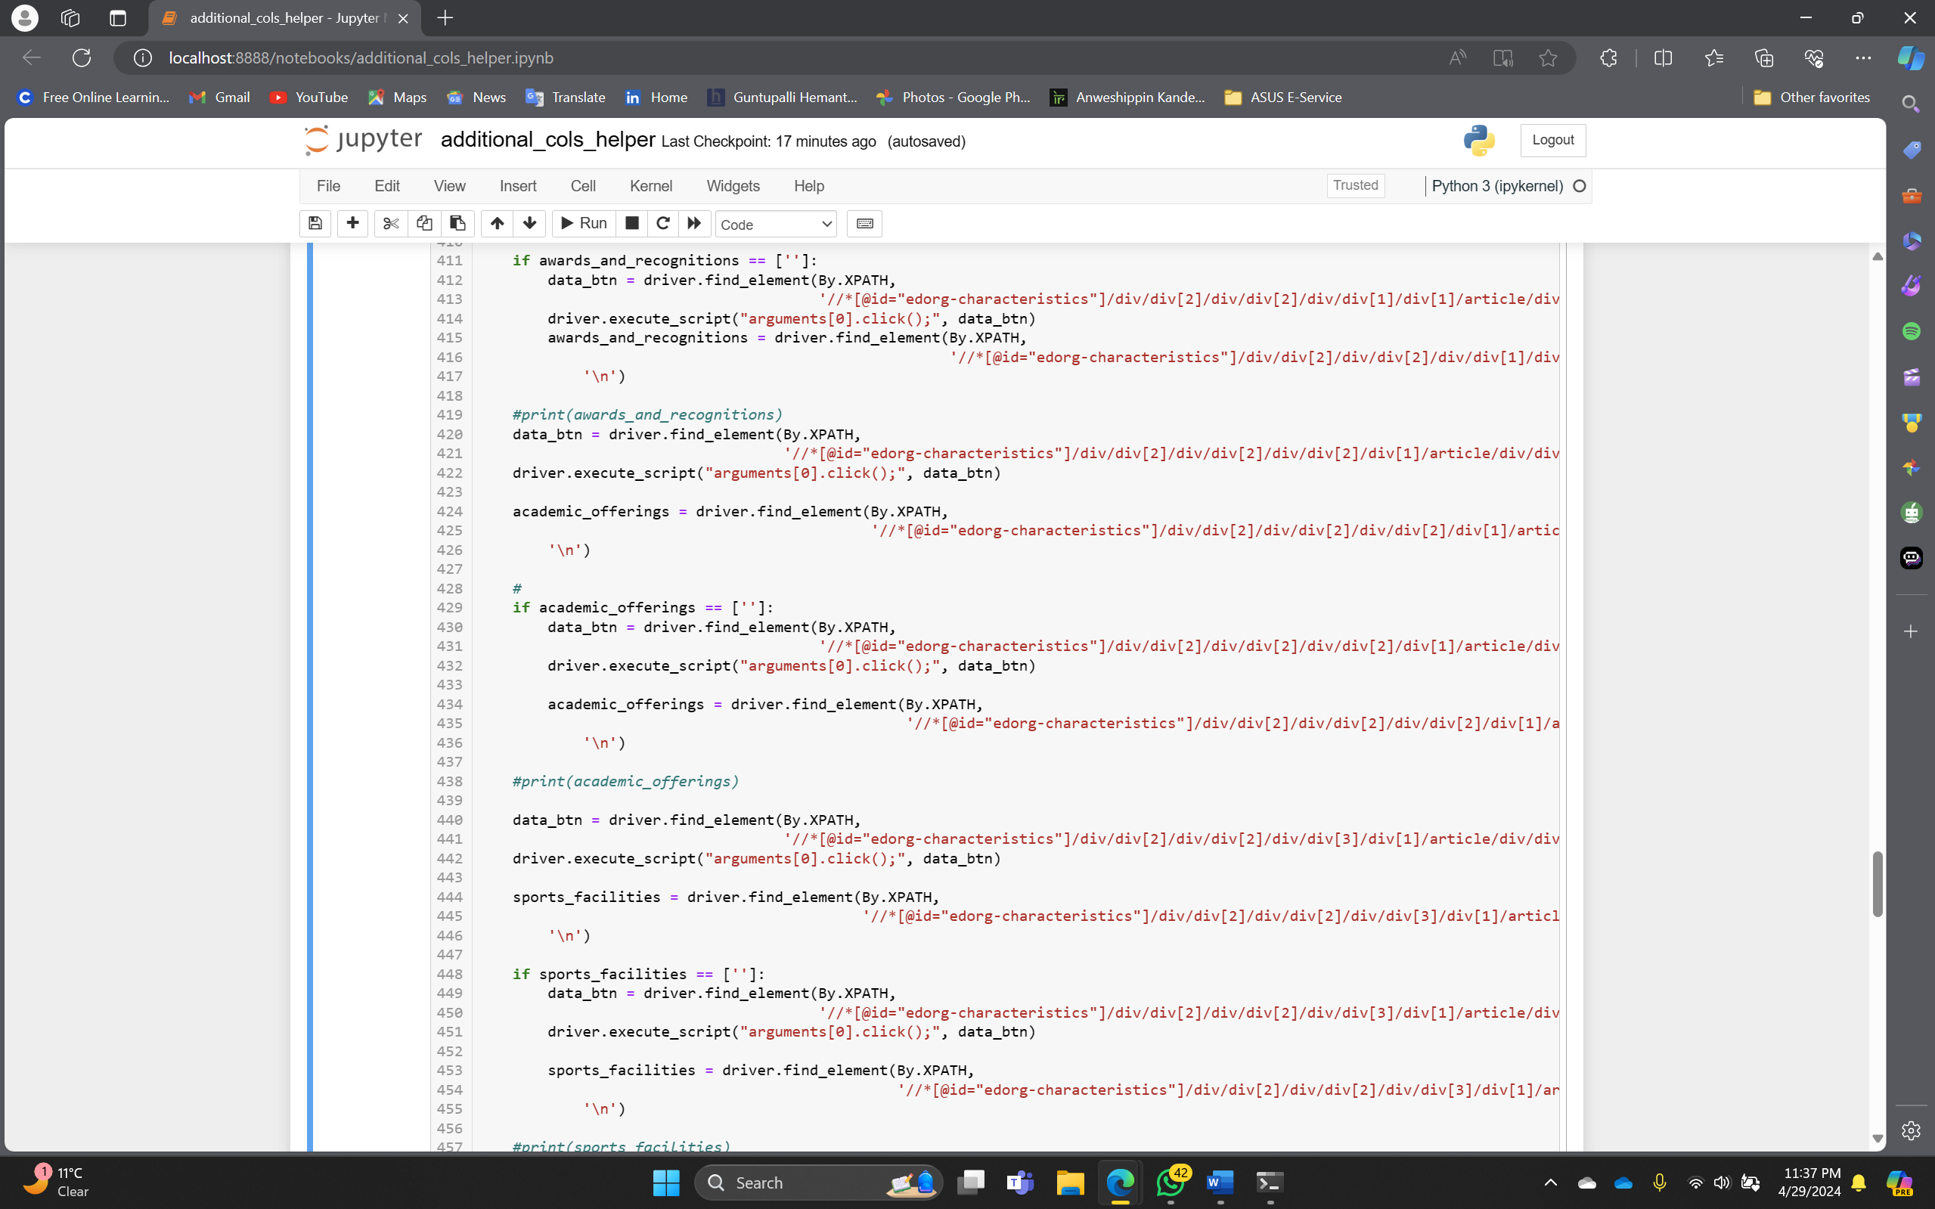

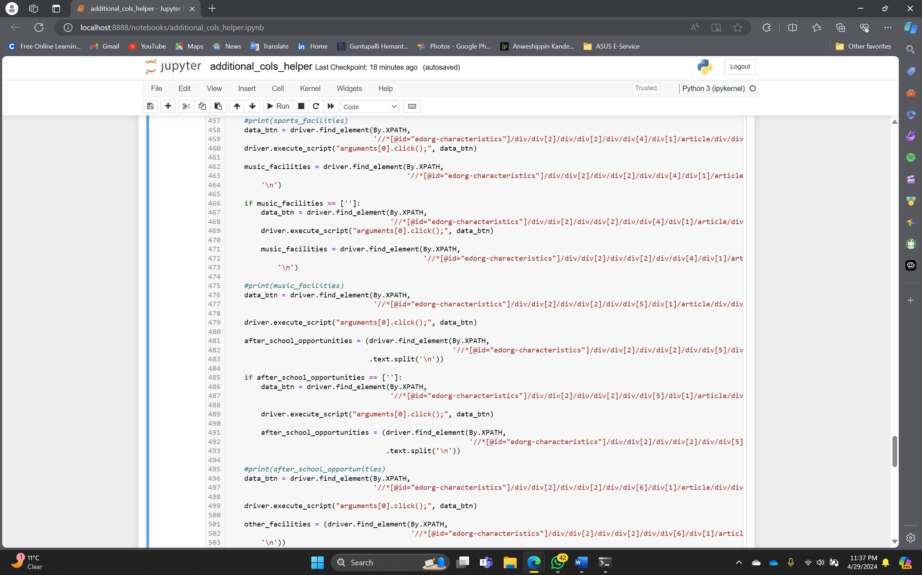

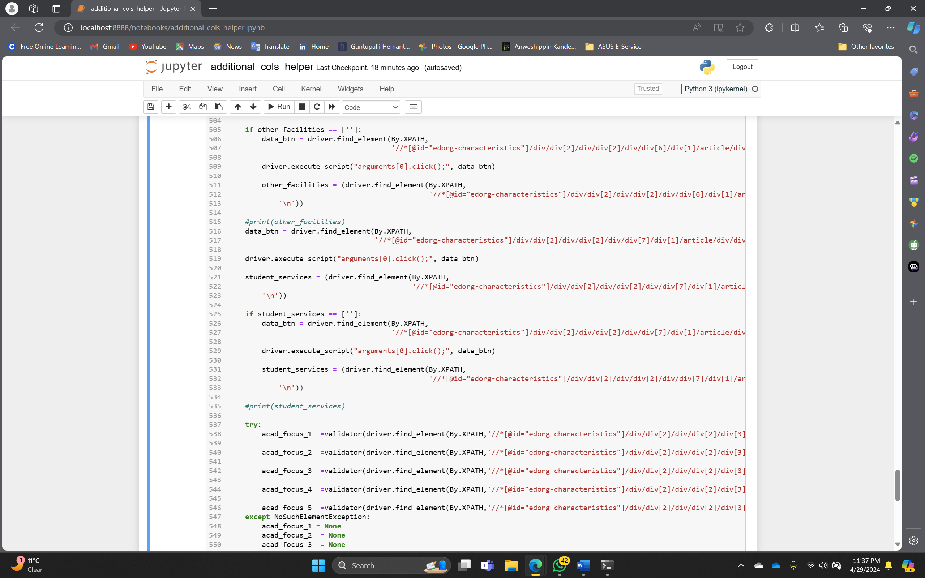

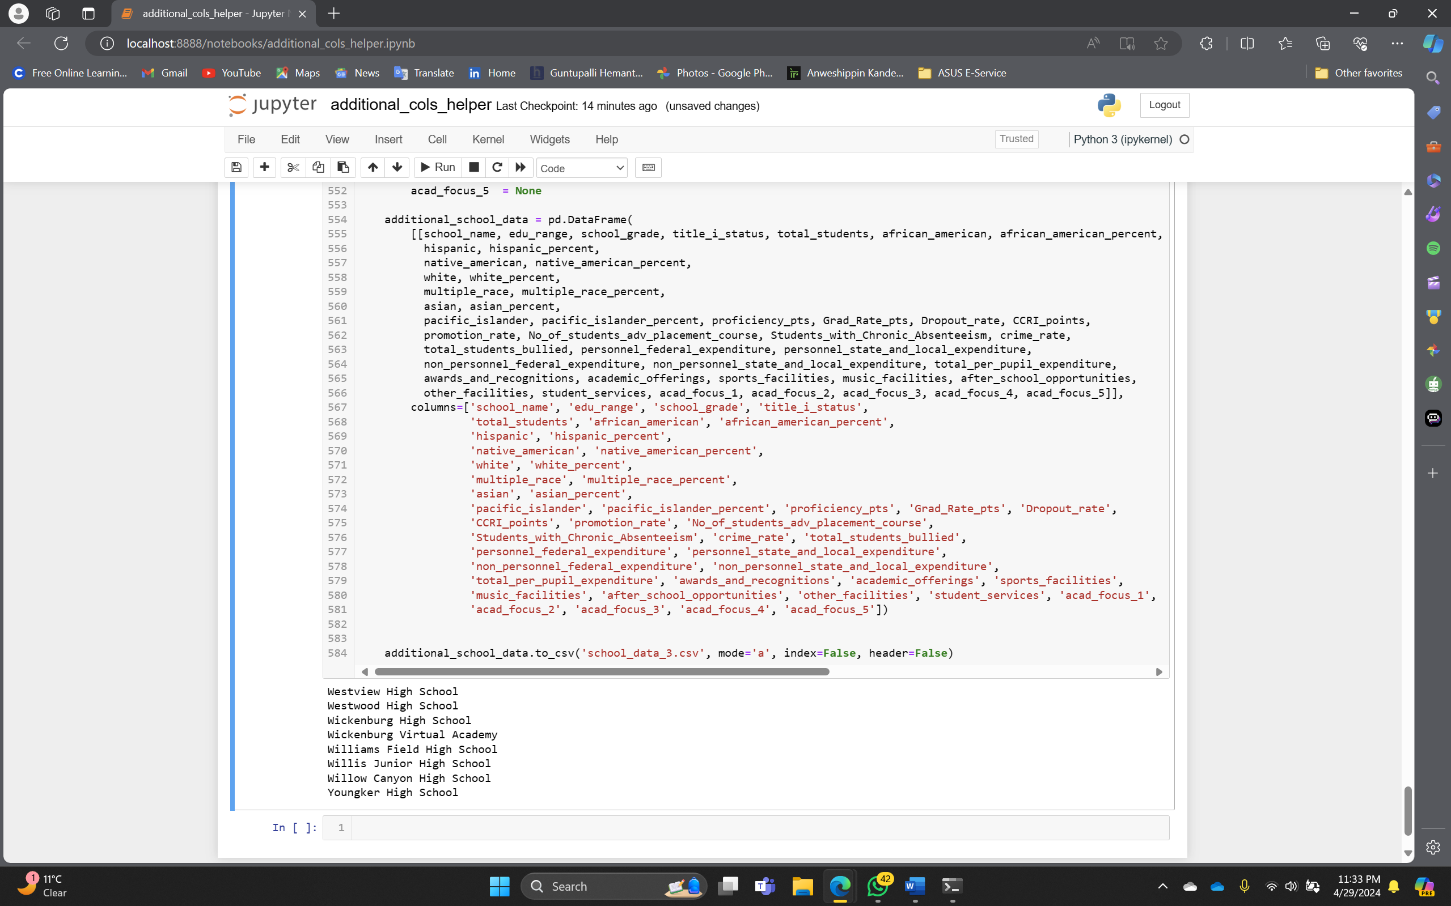

Extra Credit - Model Re-Building

Loading and Preparing Additional School Data

We will now load additional school data from a CSV file and performs data preparation steps. The school_additional_raw_data DataFrame shows the first 6 rows of the raw data. The school_additional_data DataFrame is created as a deep copy of the raw data. The additional_cols list specifies the columns of interest, including awards and recognitions, academic offerings, sports facilities, music facilities, after-school opportunities, other facilities, and student services.

Code

school_additional_raw_data = pd.read_csv("../511_project_with_extra_cols.csv")

school_additional_raw_data.head(6)

school_additional_data = school_additional_raw_data.copy(deep=True)

school_additional_data.head(5)

additional_cols = ['awards_and_recognitions',

'academic_offerings',

'sports_facilities',

'music_facilities',

'after_school_opportunities',

'other_facilities',

'student_services']

Image

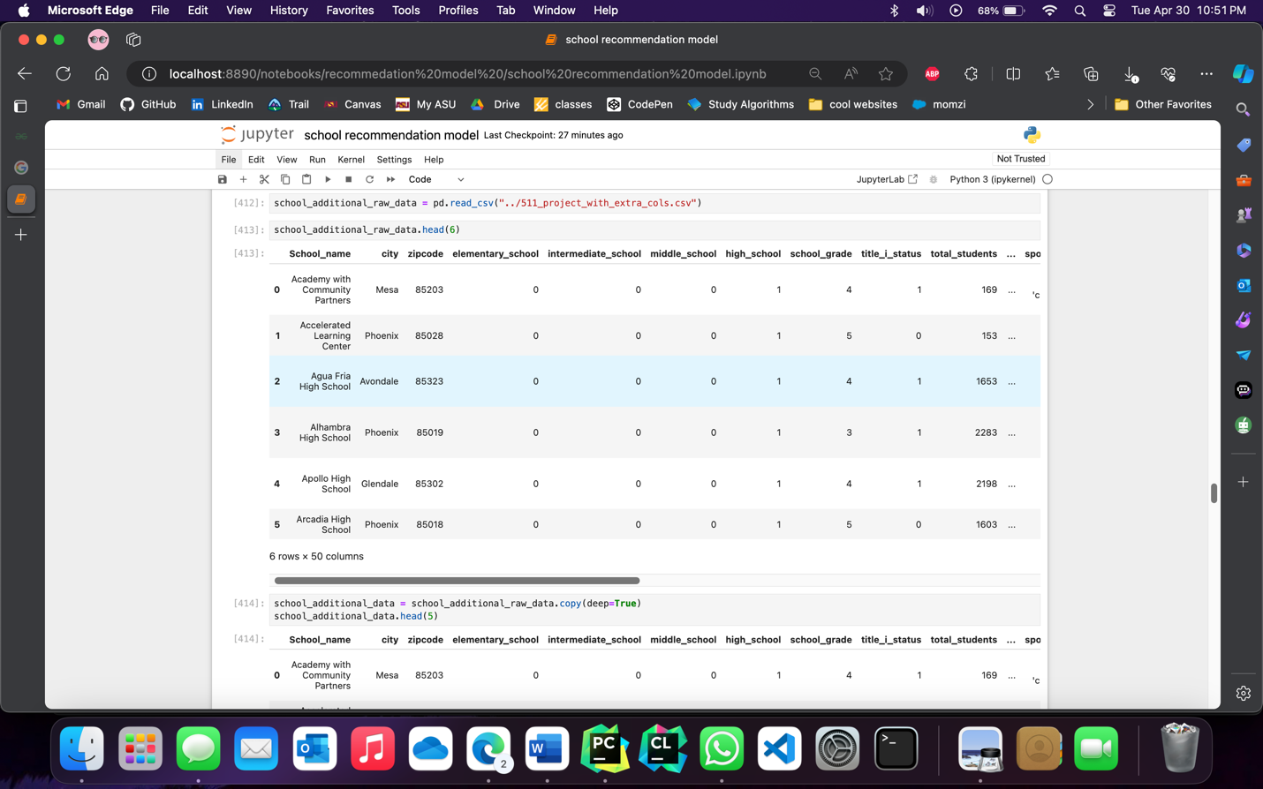

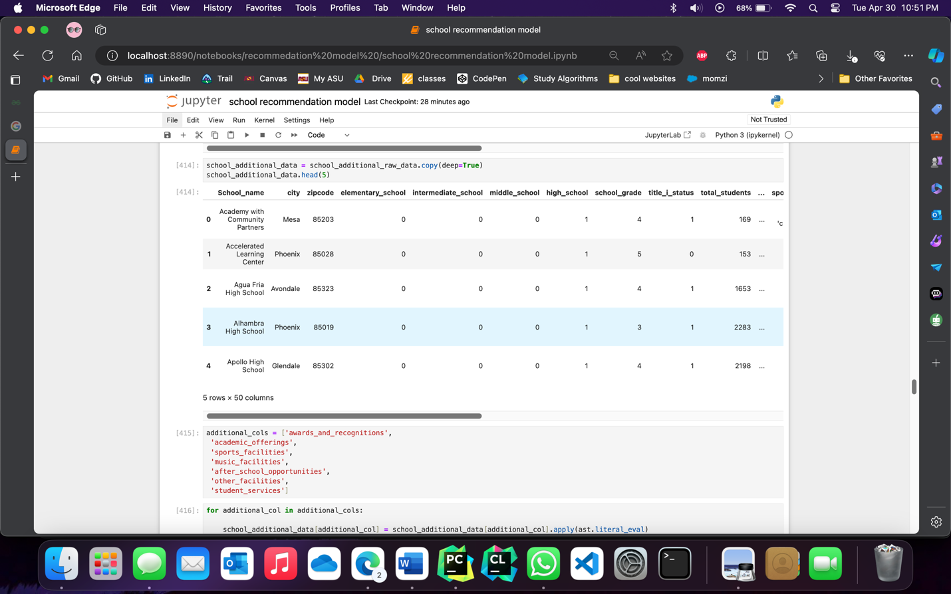

Conversion and One-Hot Encoding of Categorical Columns

This code performs conversion and one-hot encoding on multiple categorical columns in the school_additional_raw_data DataFrame. It iterates through each column specified in the additional_cols list and applies the necessary transformations. The resulting one-hot encoded data is then concatenated with the original DataFrame, replacing the original categorical columns.

Code

for additional_col in additional_cols:

school_additional_data[additional_col] = school_additional_data[additional_col].apply(ast.literal_eval)

one_hot_genres_df = school_additional_data[additional_col].str.get_dummies(sep=",")

mlb = MultiLabelBinarizer()

one_hot_encoded_data = mlb.fit_transform(school_additional_data[additional_col])

one_hot_df = pd.DataFrame(one_hot_encoded_data, columns=mlb.classes_)

columns = one_hot_df.columns.tolist()

columns_to_drop = []

numeric_patterns = re.compile(r"\d\.\d")

for col in columns:

if sum(one_hot_df[col])==1:

columns_to_drop.append(col)

elif numeric_patterns.match(col) or col.isnumeric():

columns_to_drop.append(col)

elif len(col) > 50:

columns_to_drop.append(col)

# print(col)

if 'No data available'not in columns_to_drop:

columns_to_drop.append('No data available')

one_hot_df.drop(columns=columns_to_drop,inplace=True,axis=1)

school_additional_data = pd.concat([school_additional_data.drop(additional_col, axis=1), one_hot_df], axis=1)

school_additional_data.head(5)

Images

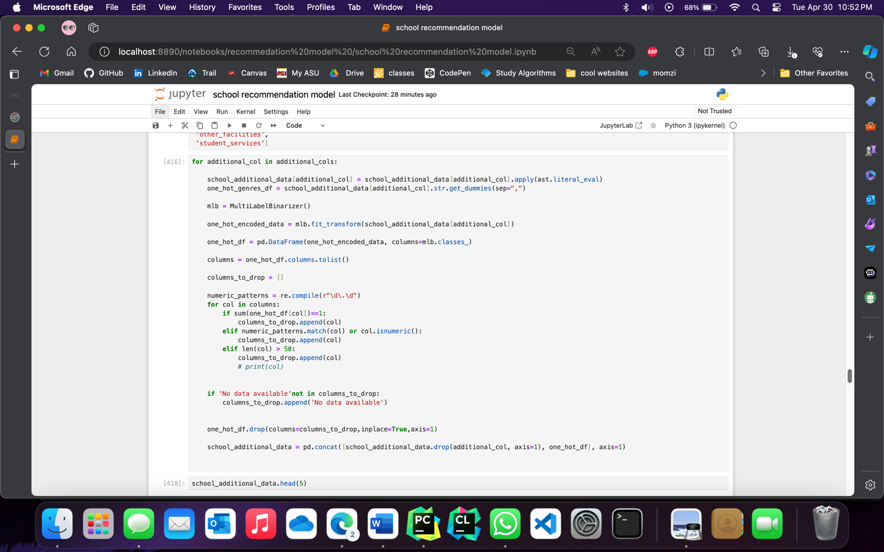

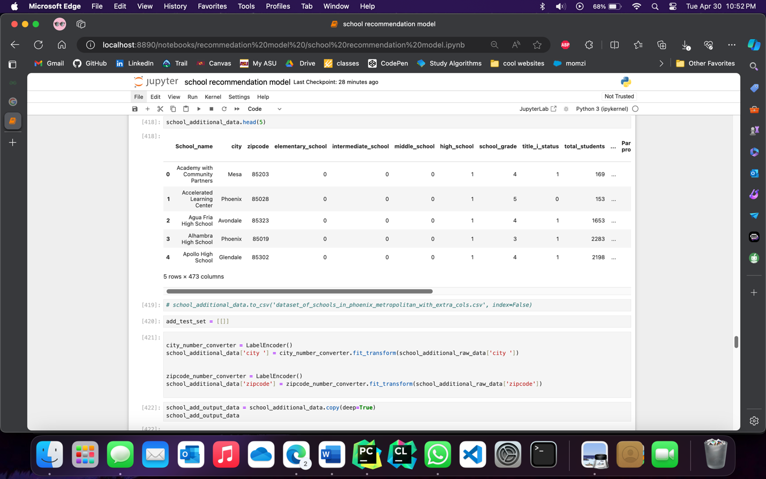

Preparing Additional School Test Set

We will now prepare a test set for additional school data. An empty list, add_test_set, is initialized. Label encoding is performed on the 'city' and 'zipcode' columns of the school_additional_data DataFrame using LabelEncoder. The user is prompted to enter the full name of a school. If a matching school name is found in the data, the corresponding row is dropped from school_additional_data and added to the add_test_set. The resulting test set is displayed, converted to integer values, and its shape is shown.

Code

add_test_set = [[]]  
  
city_number_converter = LabelEncoder()  
school_additional_data['city '] = city_number_converter.fit_transform(school_additional_raw_data['city '])  
  
  
zipcode_number_converter = LabelEncoder()  
school_additional_data['zipcode'] = zipcode_number_converter.fit_transform(school_additional_raw_data['zipcode'])

school_add_output_data = school_additional_data.copy(deep=True)

school_add_output_data

scaler = StandardScaler()

school_additional_data = pd.DataFrame(scaler.fit_transform(school_additional_data.iloc[:, 1:]))  
  
school_name_add = input("Enter the full name of the school")

if len(school_additional_raw_data["School_name "][school_additional_raw_data["School_name "].str.lower().isin([school_name_add.lower()])]) > 0:

row_index_to_drop = school_additional_raw_data["School_name "][school_additional_raw_data["School_name "].str.lower().isin([school_name_add.lower()])].index

add_test_set[0] = school_additional_data.iloc[row_index_to_drop]

school_additional_data.drop(row_index_to_drop,inplace=True)

school_add_output_data.drop(row_index_to_drop,inplace=True)  
add_test_set[0]  
add_test = pd.DataFrame(add_test_set[0])  
add_test.astype(int)  
add_test.shape

Images

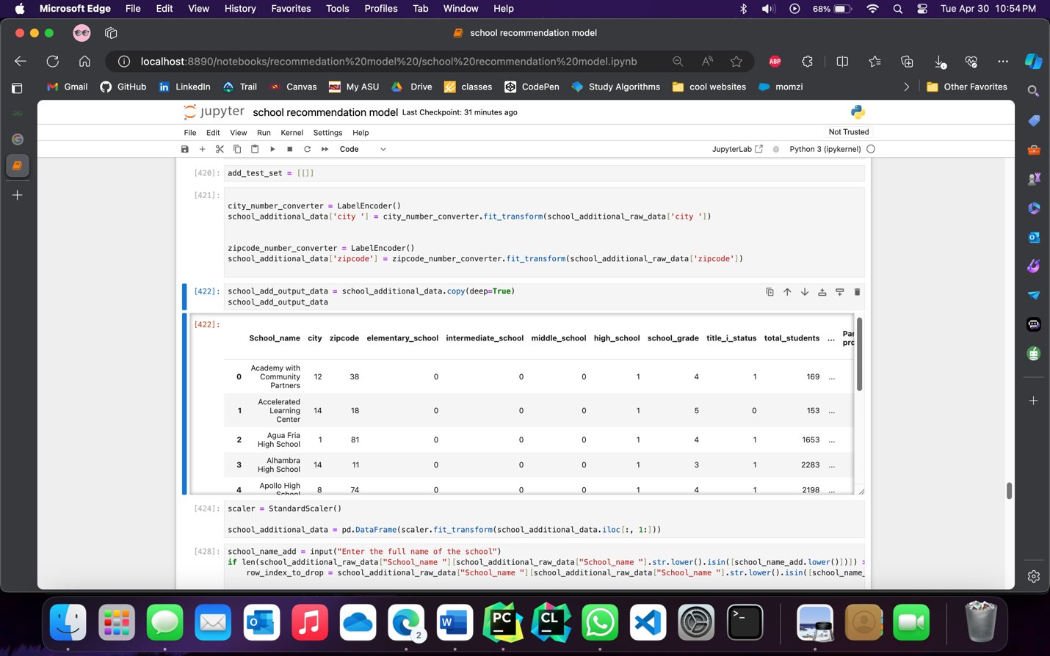

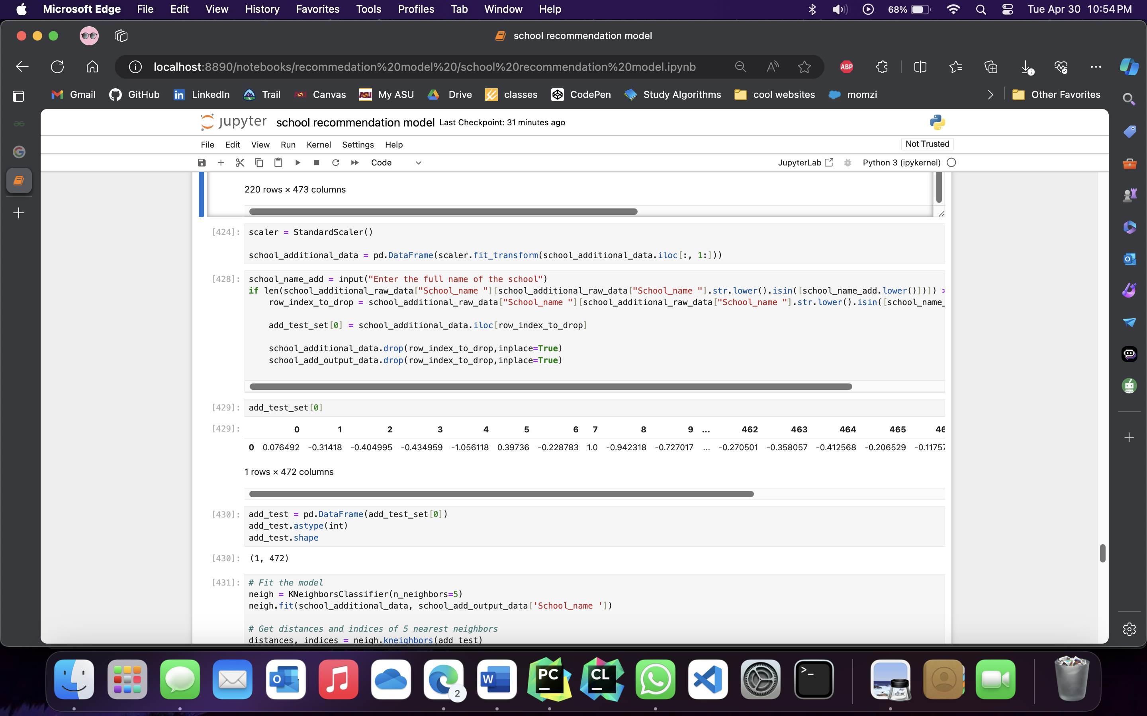

Finding the 5 Nearest Schools using K-Nearest Neighbors (KNN) Algorithm

Moving on, the code creates a K-nearest neighbors model with n_neighbors=5 and assigns it to the variable neigh. This model will be used to find the nearest neighbors based on the given features.

The K-nearest neighbors model is then fitted using the features from the school_additional_raw_data dataframe, excluding the first row. The target variable 'School_name' is also used in the fitting process, excluding the first element.

Next, the code utilizes the kneighbors() function of the K-nearest neighbors model to calculate the distances and indices of the 5 nearest neighbors for the add_test_set. These distances and indices are stored in the variables distances and indices, respectively.

Finally, a loop is used to iterate over the indices of the 5 nearest neighbors obtained from the indices variable. These indices are used to filter the school_additional_raw_data dataframe, and the names of the 5 nearest schools are printed.

Code

# Fit the model

neigh = KNeighborsClassifier(n_neighbors=5)

neigh.fit(school_additional_data, school_add_output_data['School_name '])

# Get distances and indices of 5 nearest neighbors

distances, indices = neigh.kneighbors(add_test)

# Print the names of the 5 nearest schools

output_index = []

for i in range(5):

output_index.append(indices[0][i])

school_additional_raw_data.loc[output_index]

print(distances)

Images

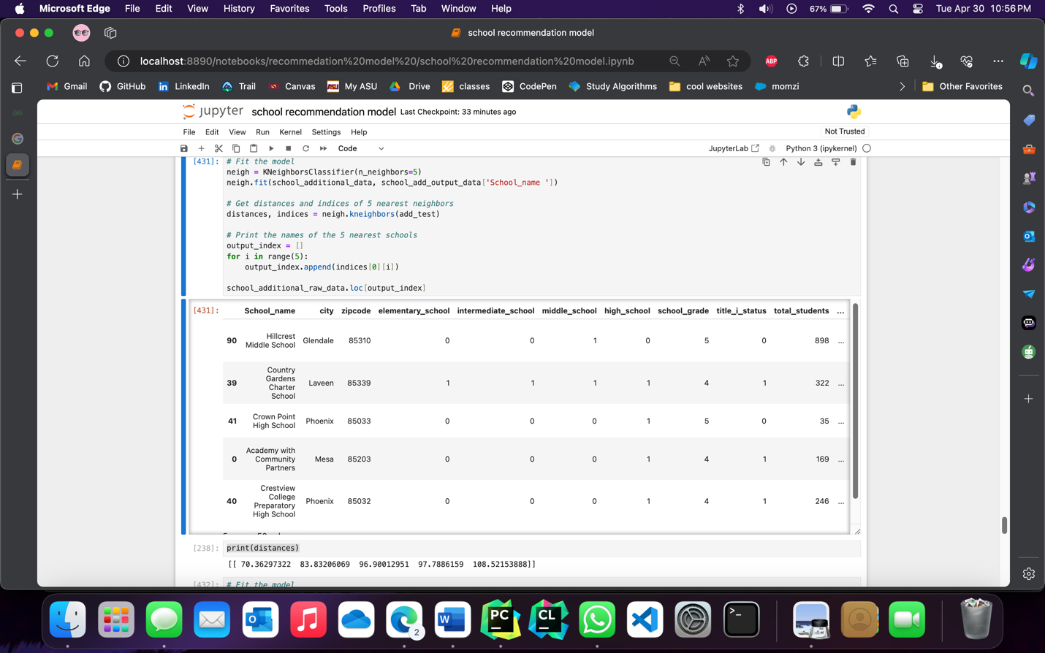

Predicting Schools with Random Forest Classifier

A Random Forest Classifier is utilized to predict schools using additional raw data. The Random Forest model is trained on the school_additional_raw_data, with the 'School_name' column as the target variable. The code obtains predictions by aggregating the outputs from multiple individual decision trees within the Random Forest. By indexing the predicted values and retrieving the corresponding rows from the school_raw_data, the code enables the extraction of relevant information for further analysis and decision-making.

Code

# Fit the model

rf = RandomForestClassifier(n_estimators=5)

rf.fit(school_additional_data, school_add_output_data['School_name '])

# Get a prediction from each tree in the forest

predictions = [tree.predict(add_test) for tree in rf.estimators_

# Print the predictions

output_index = []

for prediction in predictions:

output_index.append(int(prediction[0]))

school_additional_raw_data.loc[output_index]

Image

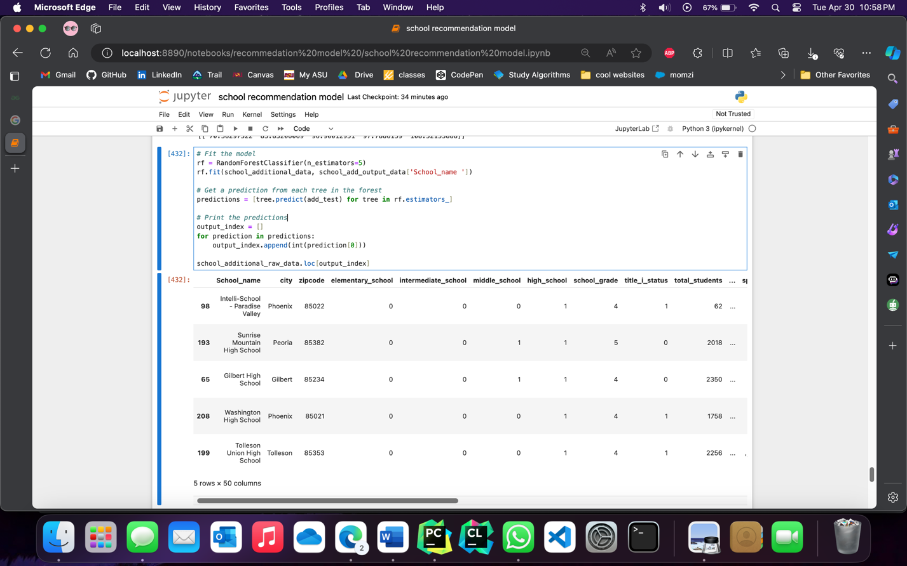

Selecting Top 5 Predicted Schools with SVC Classifier

This code snippet utilizes a Support Vector Classifier (SVC) with probability estimates to predict schools using additional raw data. After training the model, it calculates the probabilities of each class for a given test set. By sorting the probabilities and selecting the top 5 indices, the code identifies the predicted schools. It then retrieves the relevant school information from the raw data based on these predictions. This allows for further analysis and decision-making based on the top predicted schools.

Code

import numpy as np

svc = SVC(probability=True)

svc.fit(school_additional_data, school_add_output_data['School_name '])

probabilities = svc.predict_proba(add_test

top5_indices = np.argsort(probabilities, axis=1)[:, -5:]

classes = svc.classes_

top5_classes = classes[top5_indices]

school_additional_raw_data[school_additional_raw_data['School_name '].isin(top5_classes[0])]

Image

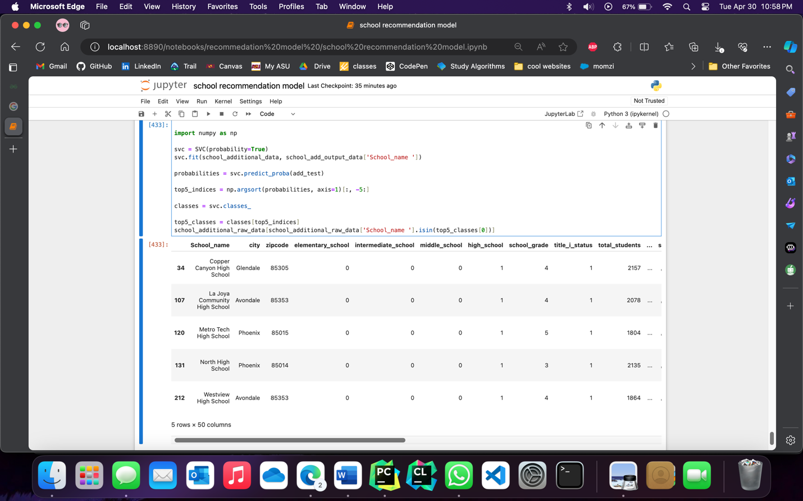

New Results

We have obtained additional data and added new columns to enhance the accuracy of our recommendations. By incorporating this additional information, we aim to provide even more precise and tailored recommendations to meet your needs. These additional features have the potential to greatly improve the quality of our recommendations, ensuring that they are more relevant and useful to you. We are constantly striving to enhance our algorithms and expand our dataset to deliver the best possible results.

Images

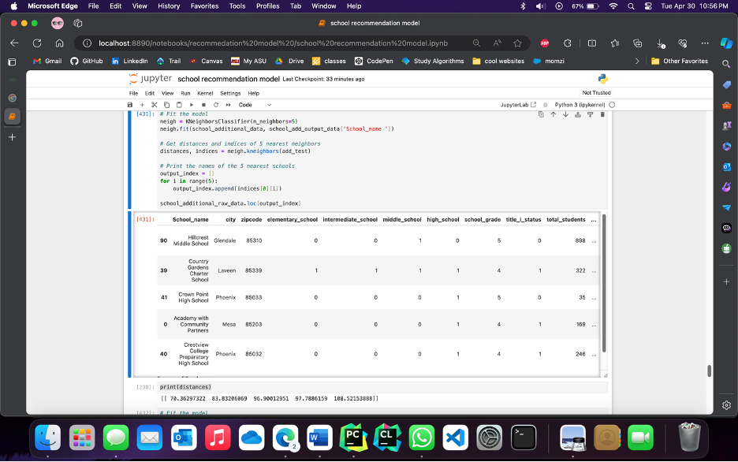

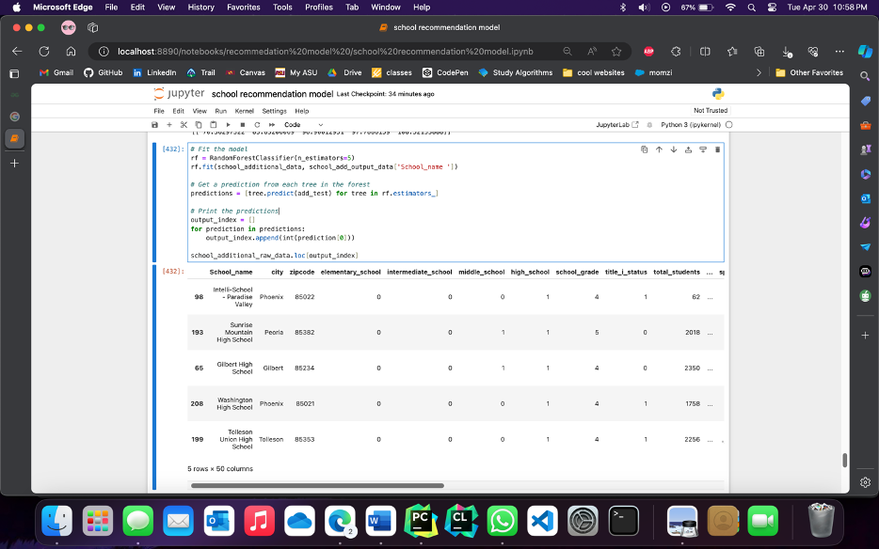



Full Code

#%%

import pandas as pd

from sklearn.preprocessing import LabelEncoder

from sklearn.neighbors import KNeighborsClassifier

from sklearn.ensemble import RandomForestClassifier

from sklearn.svm import SVC

import ast

from sklearn.preprocessing import MultiLabelBinarizer

import re

import numpy as np

from sklearn.preprocessing import StandardScaler

#%%

school_raw_data = pd.read_csv("../511_project_Step_3.csv")

#%%

school_raw_data.head(5)

#%%

school_data = school_raw_data.copy(deep=True)

school_data

#%%

city_number_converter = LabelEncoder()

school_data['city']= city_number_converter.fit_transform(school_raw_data['city'])

school_data.head(5)

#%%

zipcode_number_converter = LabelEncoder()

school_data['zipcode']= zipcode_number_converter.fit_transform(school_raw_data['zipcode'])

school_data.head(5)

#%%

expense_columns_to_drop = school_raw_data.columns[33:37].to_list()

expense_columns_to_drop

#%%

school_data.drop(columns=expense_columns_to_drop,inplace=True, axis=1)

school_data.head(5)

#%%

def range_exporter(n, column_name):

n = int(n)

# 0 = less

# 1 = more

if n == 0:

return school_data[column_name].quantile([0.40])[0.40]

elif n == 1:

return school_data[column_name].quantile([0.60])[0.60]

elif n == 2:

return school_data[column_name].quantile([0.80])[0.80]

#%%

testSet = [[]]

#%%

school_output_data = school_data.copy(deep=True)

school_output_data

#%%

scaler = StandardScaler()

school_data = pd.DataFrame(scaler.fit_transform(school_data.iloc[:,1:]))

#%%

user_input = int(input("Do you have a school in mind or do you want to describe your ideal school \n 0 = Describe school\n 1 = Enter school name "))

#%%

if user_input == 1:

school_name = input("Enter the full name of the school")

if len(school_raw_data["School_name"][school_raw_data["School_name"].str.lower().isin([school_name.lower()])]) > 0:

row_index_to_drop = school_raw_data["School_name"][school_raw_data["School_name"].str.lower().isin([school_name.lower()])].index

testSet[0] = school_data.iloc[row_index_to_drop]

school_data.drop(row_index_to_drop,inplace=True)

school_output_data.drop(row_index_to_drop,inplace=True)

else:

city_or_zipcode_selecter = int(input("Do you want to specify the city or zipcode \n 0 = City \n 1 = Zipcode"))

if city_or_zipcode_selecter ==0:

testSet[0].append(city_number_converter.transform([input("Enter the city you want the school")])[0])

school_data.drop(columns=['zipcode'],inplace=True, axis=1)

else:

testSet[0].append(zipcode_number_converter.transform([input("Enter the zipcode you want the school")])[0])

school_data.drop(columns=['city'],inplace=True, axis=1)

testSet[0].append(input("Should the school have elementary level classes: \n 0 = No \n 1 = Yes"))

testSet[0].append(input("Should the school have intermediate level classes: \n 0 = No \n 1 = Yes"))

testSet[0].append(input("Should the school have middle level classes: \n 0 = No \n 1 = Yes"))

testSet[0].append(input("Should the school have high level classes: \n 0 = No \n 1 = Yes"))

testSet[0].append(input("Enter school grade constraints: [1-5]\n 1 being least and 5 being highest"))

testSet[0].append(input("Should the school have Title I: \n 0 = No \n 1 = Yes"))

testSet[0].append( range_exporter(input("Enter the minimum number of students you want in the school: \n 0 = Less than 1000 \n 1 = Greater than 1000"),'total_students'))

# if int(input("Do you want to specify any race contraints? \n 0 = No \n 1 = Yes")) ==1:

race = int(input("Enter your race constraint \n 0 = African American \n 1 = Hispanic \n 2 = Native American\n 3 = White\n 4 = Multiple Race \n 5 = Asian\n 6 = Pacific Islander "))

race_columns_to_drop = school_raw_data.columns[10:24].to_list()

if school_raw_data.columns[(race*2) +11 -1] in race_columns_to_drop:

race_columns_to_drop.remove(school_raw_data.columns[(race*2) +11 -1])

school_data.drop(columns=race_columns_to_drop,inplace=True, axis=1)

testSet[0].append(range_exporter(input("Enter the percentage of the race: \n0 = Low \n 1 = Medium \n 2 = High"),school_raw_data.columns[(race*2) +11 -1]))

testSet[0].append(range_exporter(input("Enter the proficiency points constraints: \n0 = Low \n 1 = Medium \n 2 = High"),'proficiency_pts'))

testSet[0].append(input("Enter the graduation rate constraints: [0-10]\n 0 being least and 10 being highest"))

testSet[0].append(range_exporter(input("Enter the minimum dropout rate level: \n0 = Low \n 1 = Medium \n 2 = High"),'Dropout_rate'))

testSet[0].append(range_exporter(input("Enter the CCRI points level: \n0 = Low \n 1 = Medium \n 2 = High"),'CCRI_points'))

testSet[0].append(range_exporter(input("Enter the promotion rate level: \n0 = Low \n 1 = Medium \n 2 = High"),'promotion_rate'))

testSet[0].append(range_exporter(input("Advanced placement courses support level:\n0 = Low \n 1 = Medium \n 2 = High"),'No_of_students_adv_placement_course'))

testSet[0].append(range_exporter(input("Chronic absenteeism level:\n0 = Low \n 1 = Medium \n 2 = High"),'Students_with_Chronic_Absenteeism'))

testSet[0].append(range_exporter(input("Crime rate level:\n0 = Low \n 1 = Medium \n 2 = High"),'crime_rate'))

testSet[0].append(range_exporter(input("Bullying level:\n0 = Low \n 1 = Medium \n 2 = High"),'total_students_bullied'))

testSet[0].append(range_exporter(input("Total per pupil expenditure level:\n0 = Low \n 1 = Medium \n 2 = High"),'total_per_pupil_expenditure'))

testSet[0].append(input("Should the school protect excessive distractions labeled as Social Emotional Learning: \n 0 = No \n 1 = Yes"))

testSet[0].append(input("Should the school/district appropriately respect all students as individuals: \n 0 = No \n 1 = Yes"))

testSet[0].append(input("Should the school/district fully support teacher discipline recommendations: \n 0 = No \n 1 = Yes"))

testSet[0].append(input("Should the school teach sexual content that is developmentally appropriate: \n 0 = No \n 1 = Yes"))

testSet[0].append(input("Should the curriculum at school not expose students to explicit or graphic content that is developmentally inappropriate: \n 0 = No \n 1 = Yes"))

#%%

testSet[0]

#%%

test = pd.DataFrame(testSet[0])

test.astype(int)

school_output_data.shape

#%%

school_output_data.shape

#%%

# Fit the model

neigh = KNeighborsClassifier(n_neighbors=5)

neigh.fit(school_data, school_output_data['School_name'])

# Get distances and indices of 5 nearest neighbors

distances, indices = neigh.kneighbors(test)

# Print the names of the 5 nearest schools

output_index = []

for i in range(5):

output_index.append(indices[0][i])

school_raw_data.loc[output_index]

#%%

# Fit the model

rf = RandomForestClassifier(n_estimators=5)

rf.fit(school_data, school_output_data['School_name'])

# Get a prediction from each tree in the forest

predictions = [tree.predict(test) for tree in rf.estimators_]

# Print the predictions

output_index = []

for prediction in predictions:

output_index.append(int(prediction[0]))

school_raw_data.loc[output_index]

#%%

# Fit the model with probability=True

svc = SVC(probability=True)

svc.fit(school_data, school_output_data['School_name'])

# Get class probabilities

probabilities = svc.predict_proba(test)

# Get the top 5 class indices

top5_indices = np.argsort(probabilities, axis=1)[:,-5:]

# Get the class labels

classes = svc.classes_

# Get the top 5 class labels

top5_classes = classes[top5_indices]

school_raw_data[school_raw_data['School_name'].isin(top5_classes[0])]

#%%

school_additional_raw_data = pd.read_csv("../511_project_with_extra_cols.csv")

#%%

school_additional_raw_data.head(6)

#%%

school_additional_data = school_additional_raw_data.copy(deep=True)

school_additional_data.head(5)

#%%

additional_cols = ['awards_and_recognitions',

'academic_offerings',

'sports_facilities',

'music_facilities',

'after_school_opportunities',

'other_facilities',

'student_services']

#%%

for additional_col in additional_cols:

school_additional_data[additional_col] = school_additional_data[additional_col].apply(ast.literal_eval)

one_hot_genres_df = school_additional_data[additional_col].str.get_dummies(sep=",")

mlb = MultiLabelBinarizer()

one_hot_encoded_data = mlb.fit_transform(school_additional_data[additional_col])

one_hot_df = pd.DataFrame(one_hot_encoded_data, columns=mlb.classes_)

columns = one_hot_df.columns.tolist()

columns_to_drop = []

numeric_patterns = re.compile(r"\d\.\d")

for col in columns:

if sum(one_hot_df[col])==1:

columns_to_drop.append(col)

elif numeric_patterns.match(col) or col.isnumeric():

columns_to_drop.append(col)

elif len(col) > 50:

columns_to_drop.append(col)

# print(col)

if 'No data available'not in columns_to_drop:

columns_to_drop.append('No data available')

one_hot_df.drop(columns=columns_to_drop,inplace=True,axis=1)

school_additional_data = pd.concat([school_additional_data.drop(additional_col, axis=1), one_hot_df], axis=1)

#%%

school_additional_data.head(5)

#%%

# school_additional_data.to_csv('dataset_of_schools_in_phoenix_metropolitan_with_extra_cols.csv', index=False)

#%%

add_test_set = [[]]

#%%

city_number_converter = LabelEncoder()

school_additional_data['city '] = city_number_converter.fit_transform(school_additional_raw_data['city '])

zipcode_number_converter = LabelEncoder()

school_additional_data['zipcode'] = zipcode_number_converter.fit_transform(school_additional_raw_data['zipcode'])

#%%

school_add_output_data = school_additional_data.copy(deep=True)

school_add_output_data

#%%

scaler = StandardScaler()

school_additional_data = pd.DataFrame(scaler.fit_transform(school_additional_data.iloc[:, 1:]))

#%%

school_name_add = input("Enter the full name of the school")

if len(school_additional_raw_data["School_name "][school_additional_raw_data["School_name "].str.lower().isin([school_name_add.lower()])]) > 0:

row_index_to_drop = school_additional_raw_data["School_name "][school_additional_raw_data["School_name "].str.lower().isin([school_name_add.lower()])].index

add_test_set[0] = school_additional_data.iloc[row_index_to_drop]

school_additional_data.drop(row_index_to_drop,inplace=True)

school_add_output_data.drop(row_index_to_drop,inplace=True)

#%%

add_test_set[0]

#%%

add_test = pd.DataFrame(add_test_set[0])

add_test.astype(int)

add_test.shape

#%%

# Fit the model

neigh = KNeighborsClassifier(n_neighbors=5)

neigh.fit(school_additional_data, school_add_output_data['School_name '])

# Get distances and indices of 5 nearest neighbors

distances, indices = neigh.kneighbors(add_test)

# Print the names of the 5 nearest schools

output_index = []

for i in range(5):

output_index.append(indices[0][i])

school_additional_raw_data.loc[output_index]

#%%

print(distances)

#%%

# Fit the model

rf = RandomForestClassifier(n_estimators=5)

rf.fit(school_additional_data, school_add_output_data['School_name '])

# Get a prediction from each tree in the forest

predictions = [tree.predict(add_test) for tree in rf.estimators_]

# Print the predictions

output_index = []

for prediction in predictions:

output_index.append(int(prediction[0]))

school_additional_raw_data.loc[output_index]

#%%

import numpy as np

svc = SVC(probability=True)

svc.fit(school_additional_data, school_add_output_data['School_name '])

probabilities = svc.predict_proba(add_test)

top5_indices = np.argsort(probabilities, axis=1)[:, -5:]

classes = svc.classes_

top5_classes = classes[top5_indices]

school_additional_raw_data[school_additional_raw_data['School_name '].isin(top5_classes[0])]